**Question 3: Program to find square of a number in 8085**

**Aims and Objectives**

* To find the square of a number.
* Use lookup table to store and retrieve data.

**Discussion**

The program intends to find the square of a number from the lookup table of squares stored under the H register. The following opcodes were used:

* LXI: instructions used to load data from memory location using the memory address stored in the register pair.
* Load Accumulator from memory pointed by extended register pair, LDAX: loads the accumulator with the contents of the memory pointed to by the specified register pair.
* MOV: the content of the memory location pointed to by the HL register pair will be moved to the new specified register.
* Store Accumulator contents in memory pointed by extended register, STAX: stores the contents of the accumulator in the memory location pointed to by the specified register pair.
* Increment extended register, INX: used to add 1 to the present content of the specified register pair.
* Compare Immediate with Accumulator, CPI: used to compare the contents of the accumulator with the immediate data.
* Jump if Not Zero, JNZ: used to jump to the specified address provided in the instruction but only if the present zero flag value is 0.
* Halt and enter wait state, HLT: the CPU finishes executing the current instruction and stops further execution until a reset or an interrupt occurs.

For this program, a lookup table pointed to by the HL register pair will be used to retrieve the values stored. These values are the squares of the corresponding number. Below is a representation of the lookup table:

|  |  |
| --- | --- |
| **Number** | **Squared Value** |
| 00 | 00 |
| 01 | 01 |
| 02 | 04 |
| 03 | 09 |
| 04 | 10 |
| 05 | 19 |
| 06 | 24 |
| 07 | 31 |
| 08 | 40 |
| 09 | 51 |
| 0A | 64 |
| 0B | 79 |
| 0C | 90 |
| 0D | A9 |
| 0E | C4 |
| 0F | E1 |

This lookup table is stored at the memory location 6200H.

**Results and Analysis**

The complete program is as shown below:

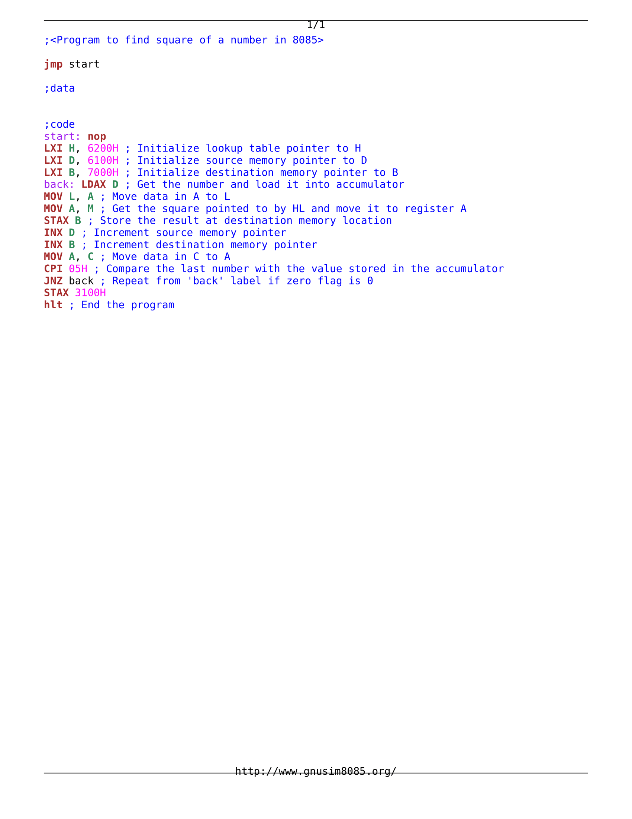

The initial state of the program is as shown in Figure 1 below/the program sequence is as follows:

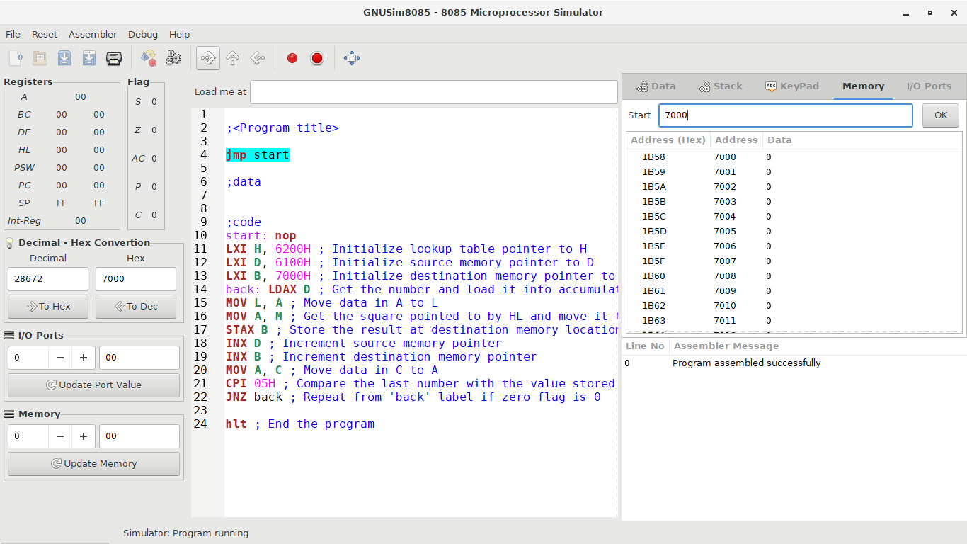

The program starts with the program pointing to the **jmp** instruction by the program counter set to 00 00.

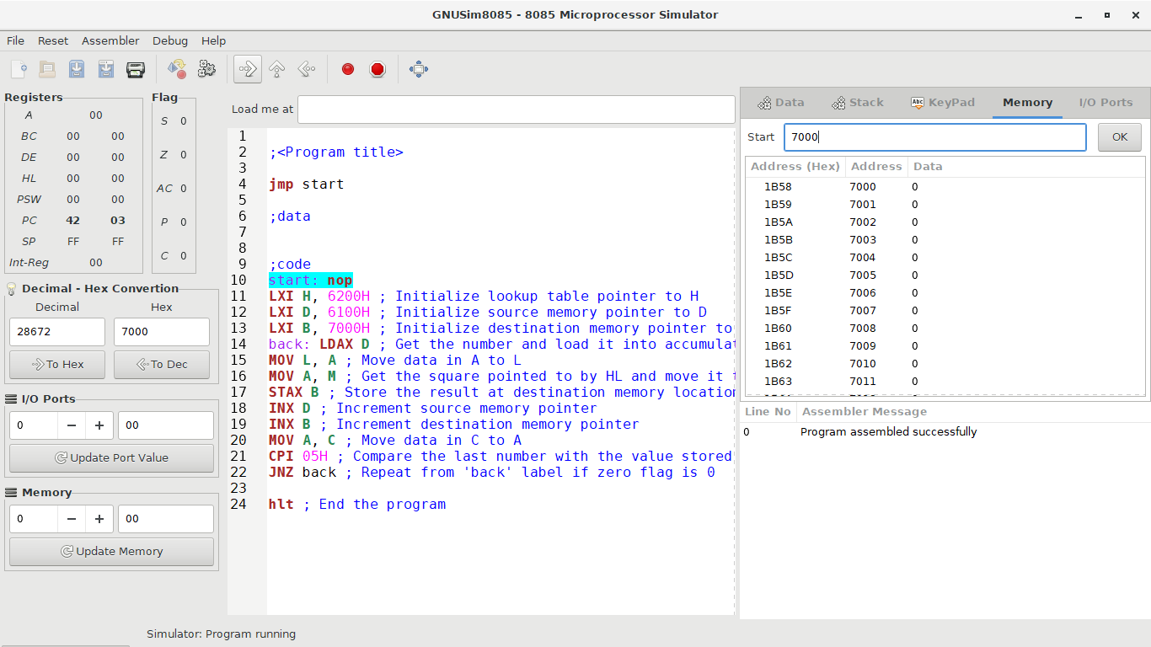

The **jmp** instruction has no conditions and once executed, the program moves to the start label. The program counter is 42 03 as **jmp** is a three-bit instruction.

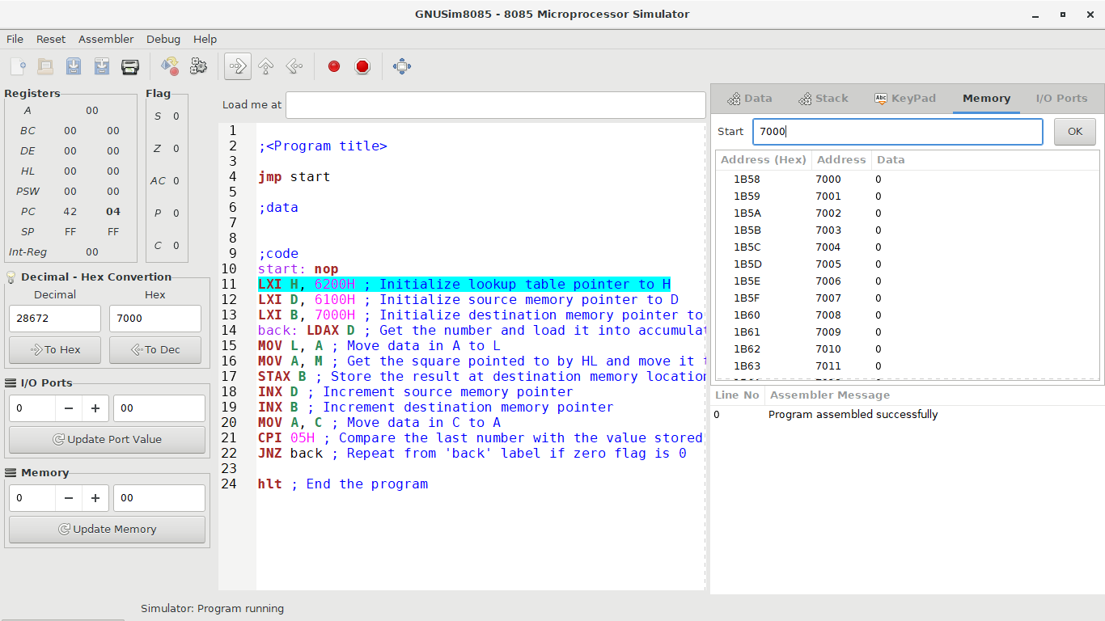

The program jumps to the **start** label. The **nop** instruction does nothing during execution. The program counter is 42 04.

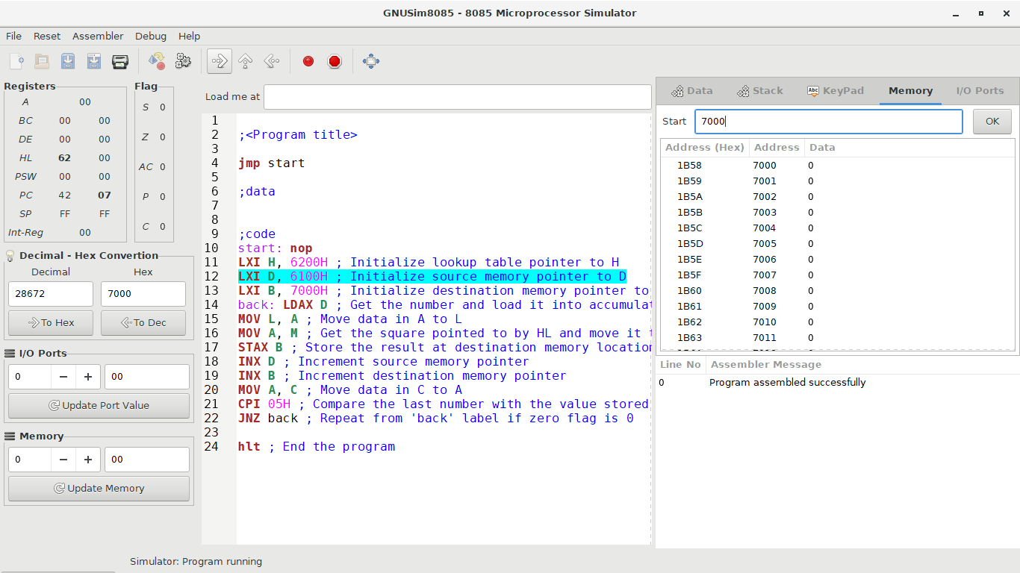

The **lxi** instruction is used to load data from memory location using the memory address 6200H. This initialises the lookup table pointer to the H of the HL pair. The program counter is 42 07.

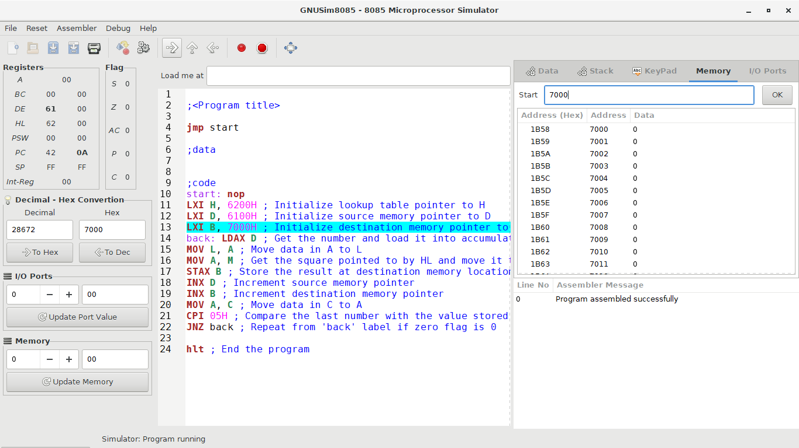

Again, the **lxi** instruction initialises the source memory pointer to the D of the DE pair. The program counter is 42 0A.

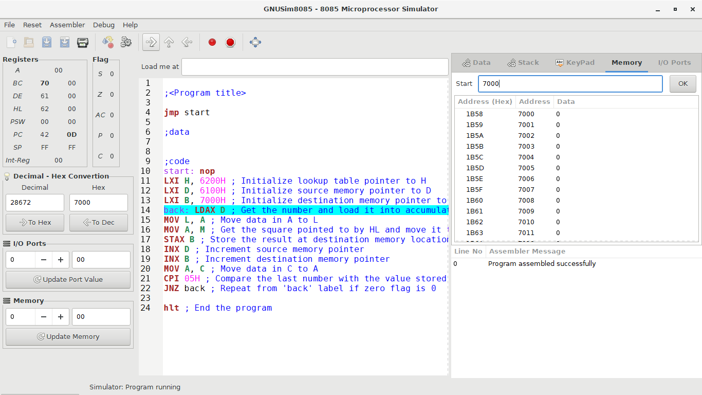

The **lxi** instruction initialises the destination memory pointer to the B of the BC pair. The program counter is 42 0D.

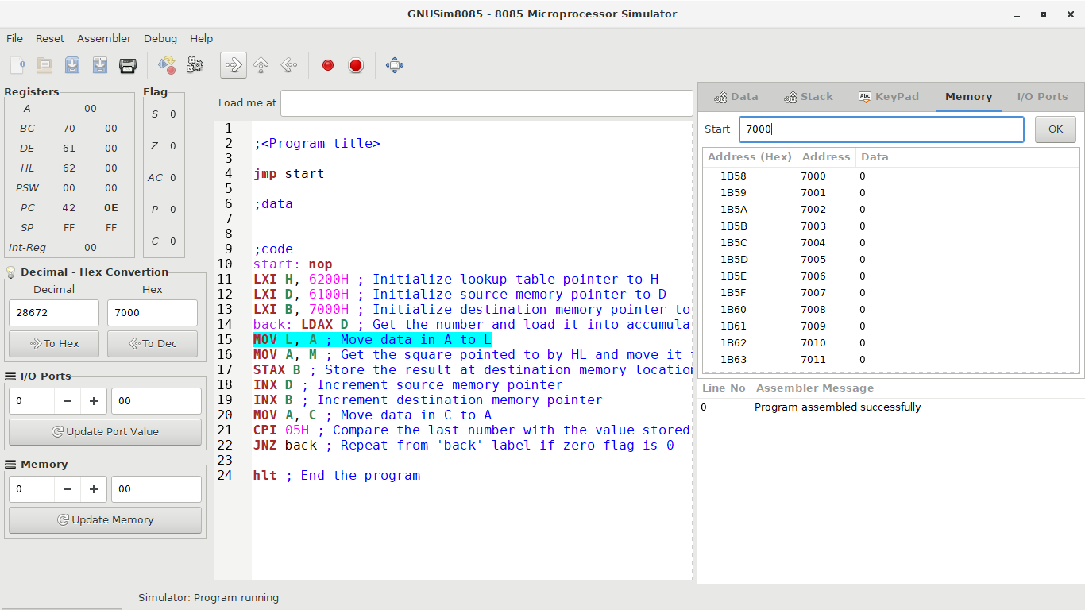

The first value in the memory location pointed to by the DE register pair is loaded into the accumulator by the **ldax** instruction. The program counter is 42 0E.

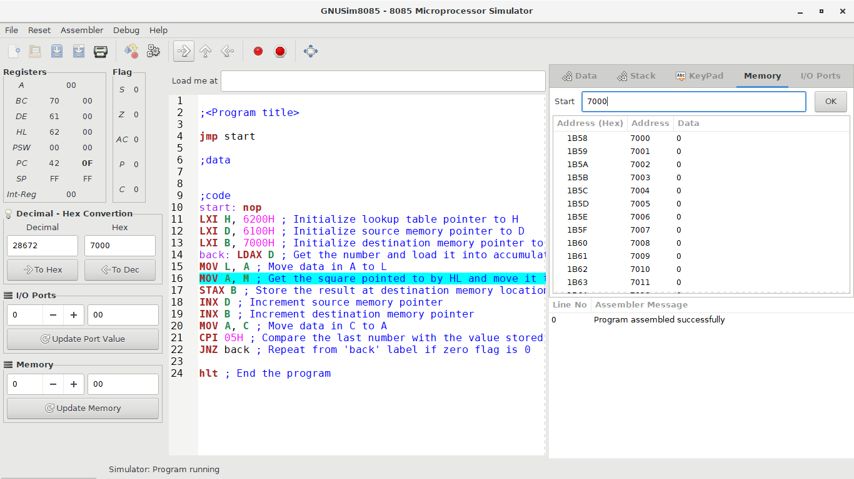

The **mov** instruction copies the contents of the accumulator to the register L. The program counter is 42 0F.

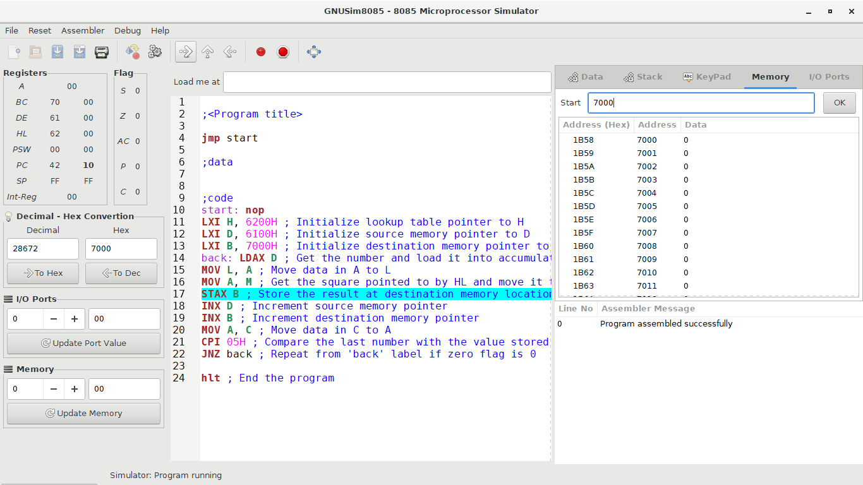

The value pointed to by the HL pair is then loaded into the accumulator from the lookup table containing the squares by the **mov** instruction. The program counter is 42 10.

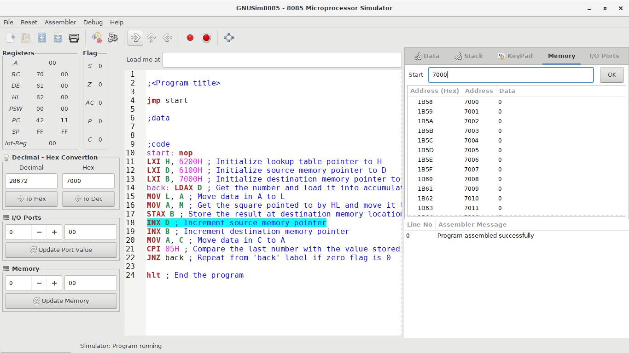

The contents of the accumulator are stored at the destination memory location pointed to by the BC register pair. The program counter is 42 11.

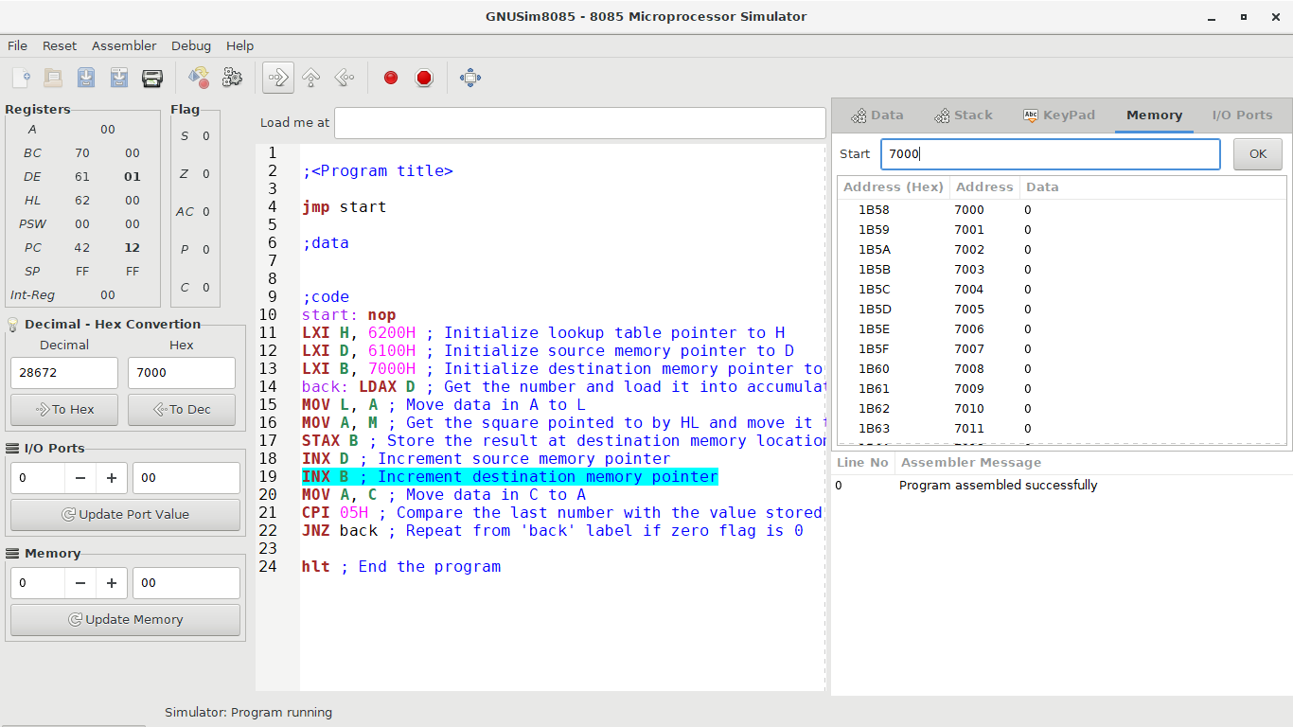

The **inx** instruction adds 1 to the present content of the DE register pair. The program counter is 42 12.

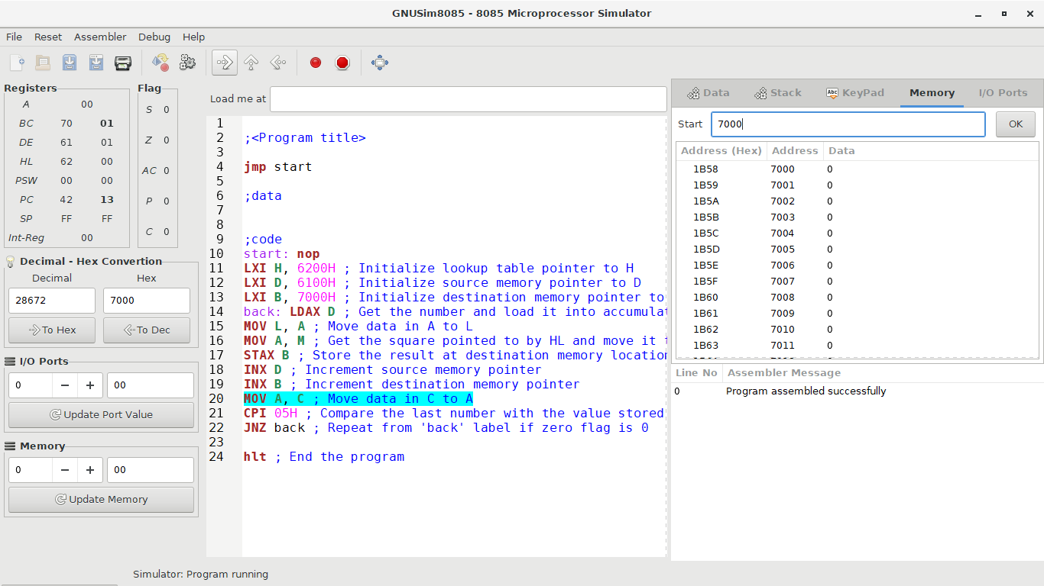

The **inx** instruction adds 1 to the present content of the BC register pair. The program counter is 42 13.

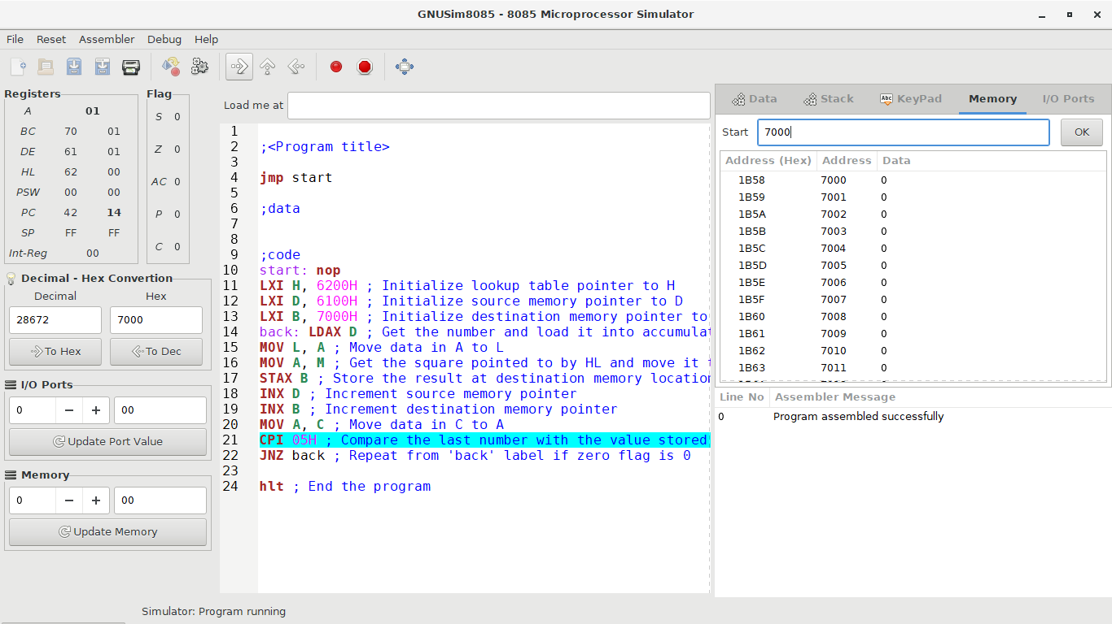

The **mov** instruction copies the contents of register C to the accumulator. The program counter is 42 14.

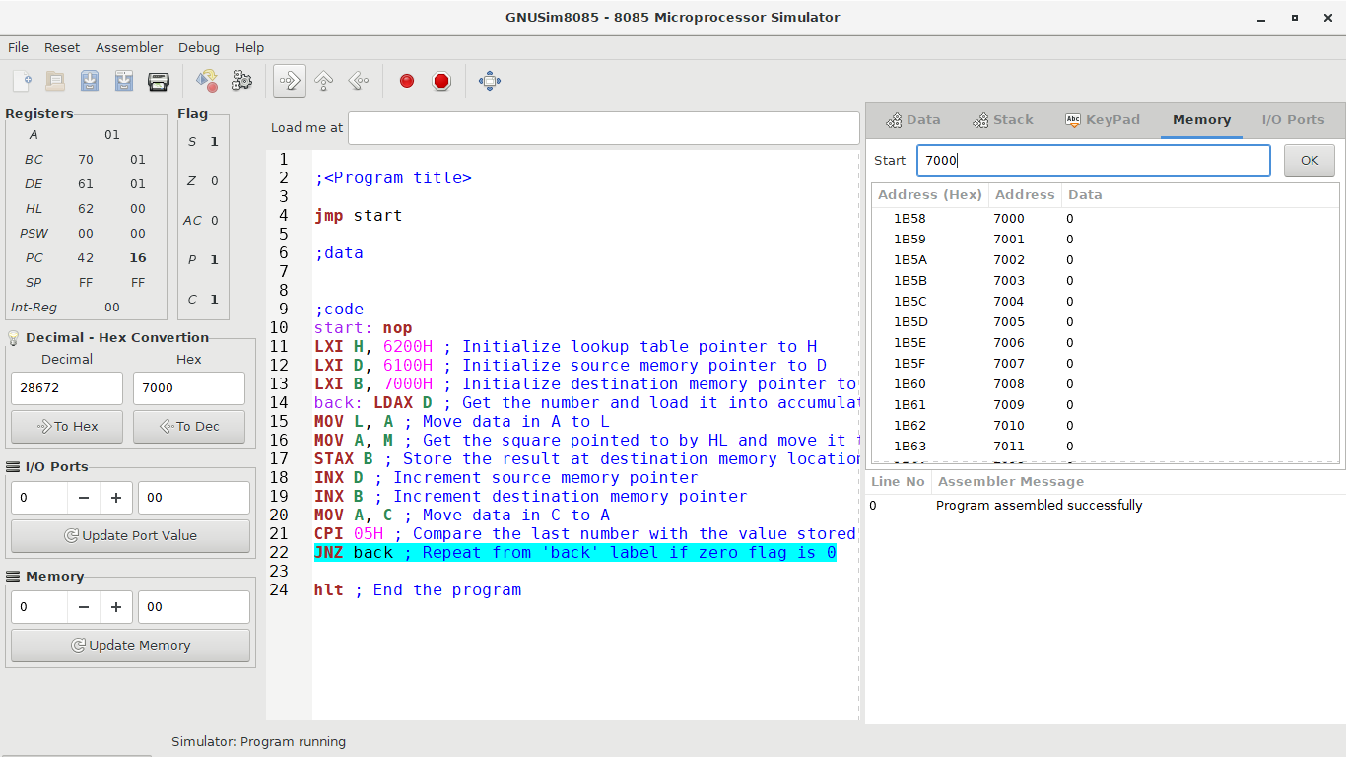

The contents of the accumulator are compared to the value 05H. The results of the instruction are 01H (Register A) – 05H = -04H and the sign, parity and carry flags are set to 1. The program counter is 42 16.

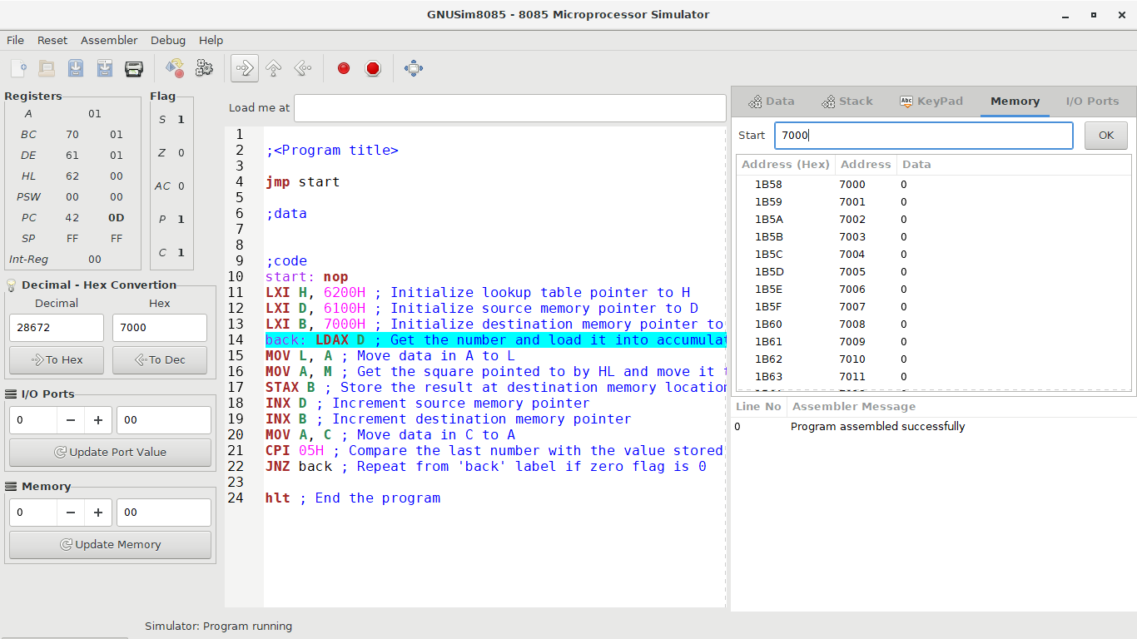

As the zero flag is 0, the conditions for the **jnz** instruction are met. Thus, the program returns to the **back** label. The program counter is 42 0D. The sequence above repeats from the **back** label for the accumulator values 02, 03 and 04 as shown in the screenshots below:

When the accumulator value is 02H:

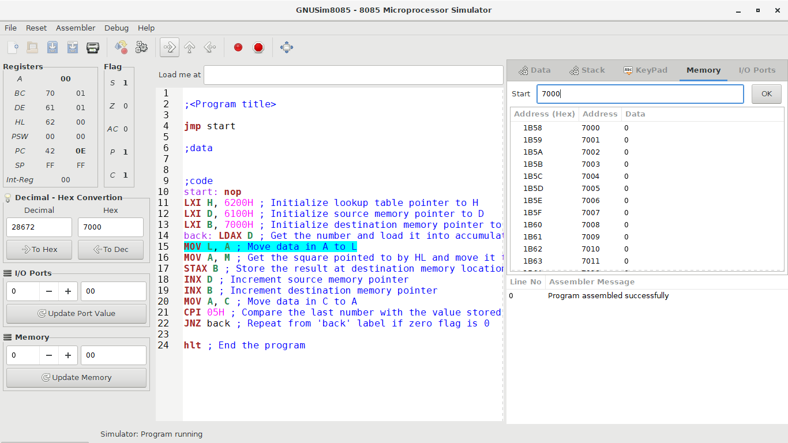

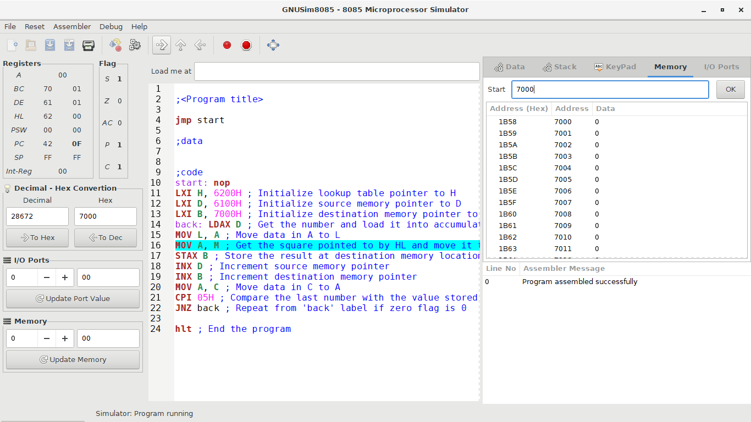

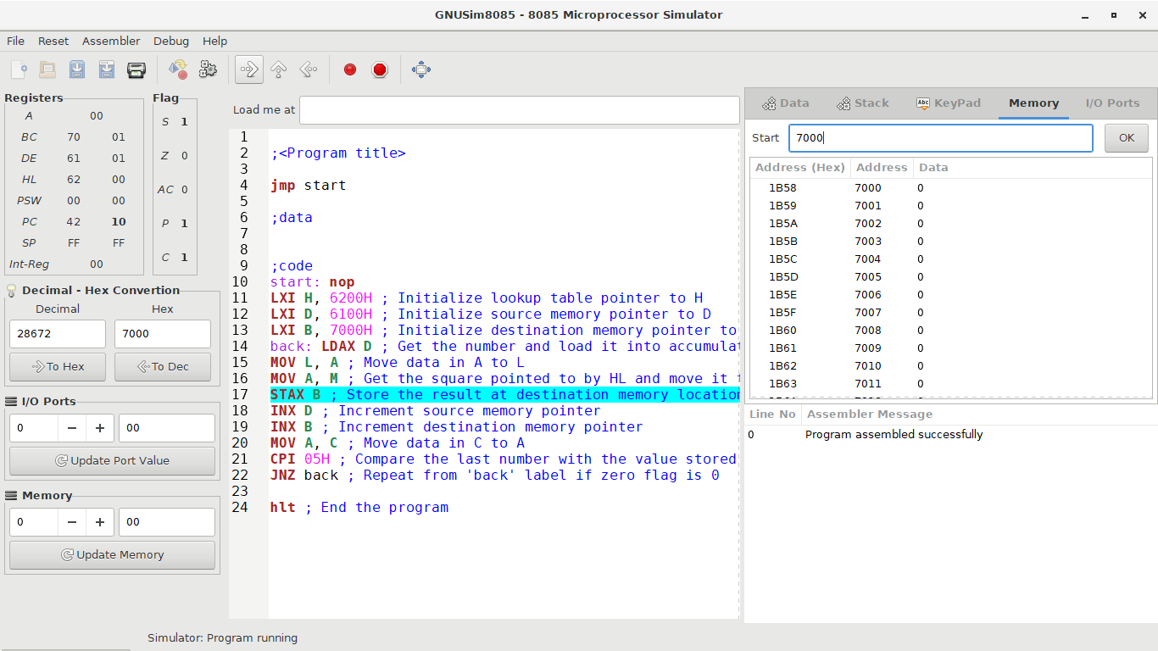

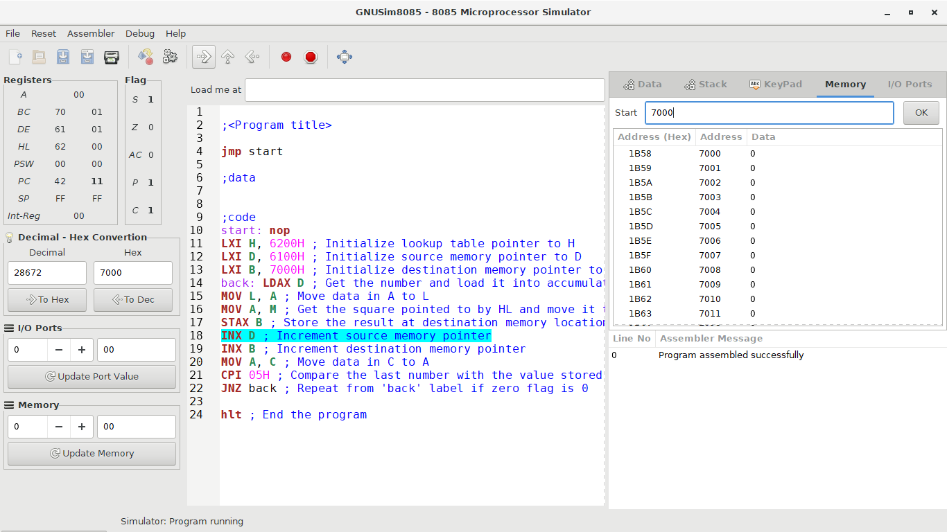

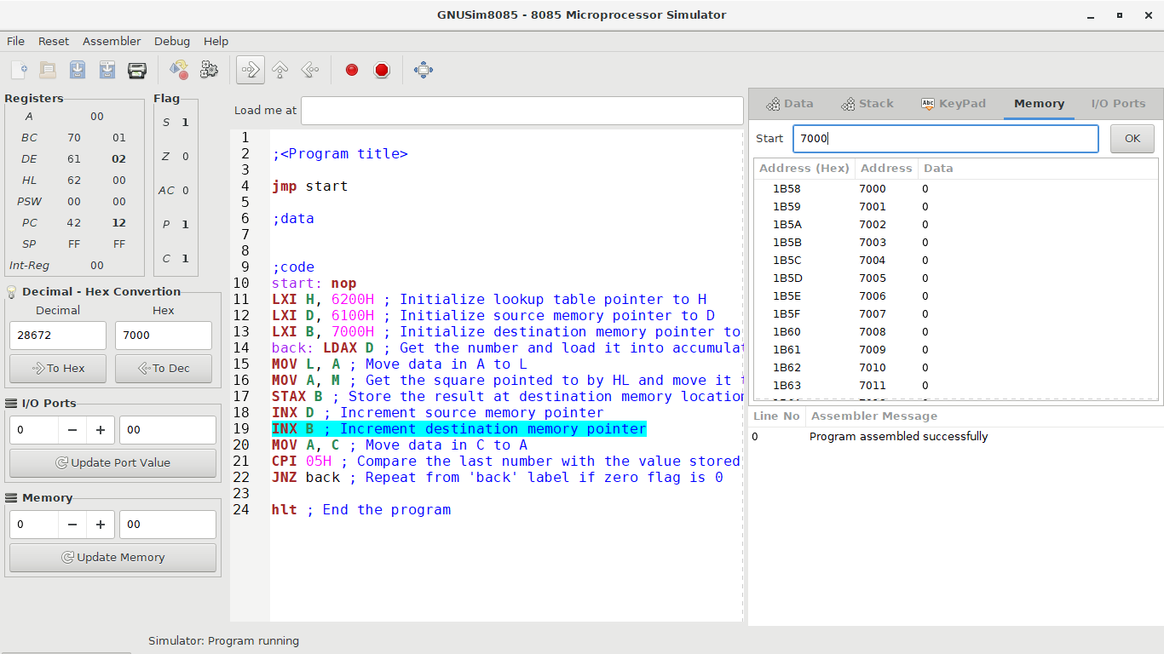

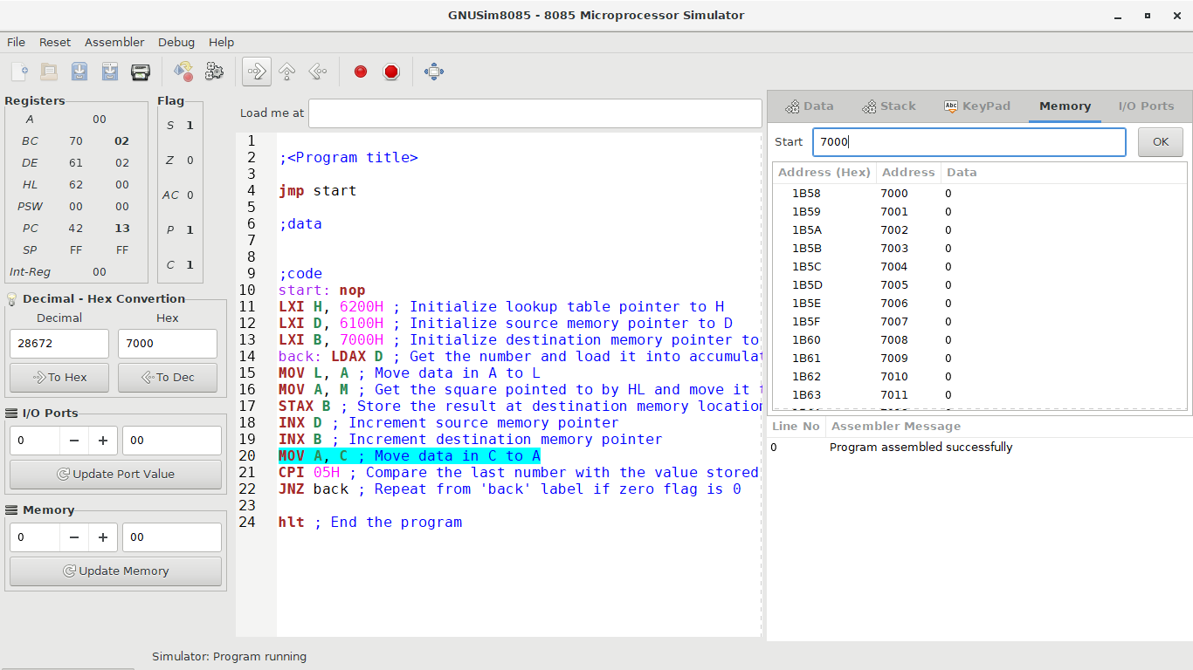

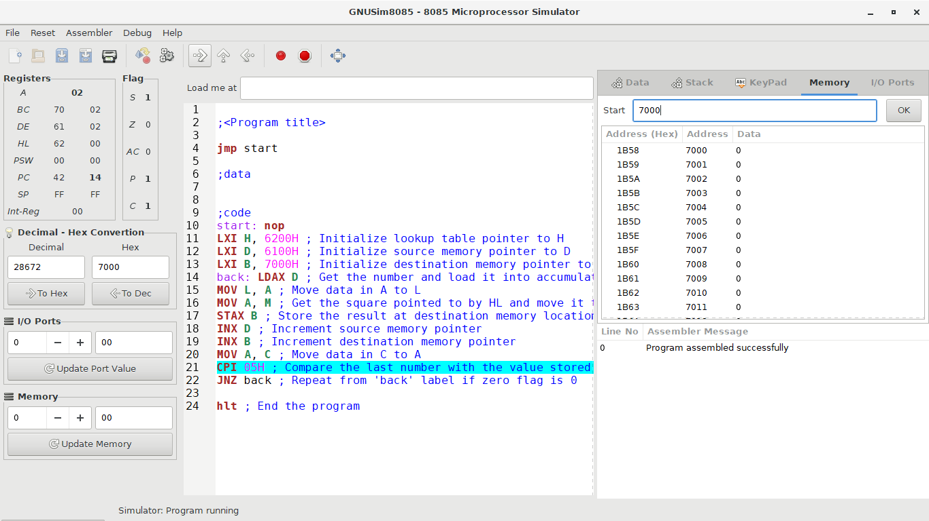

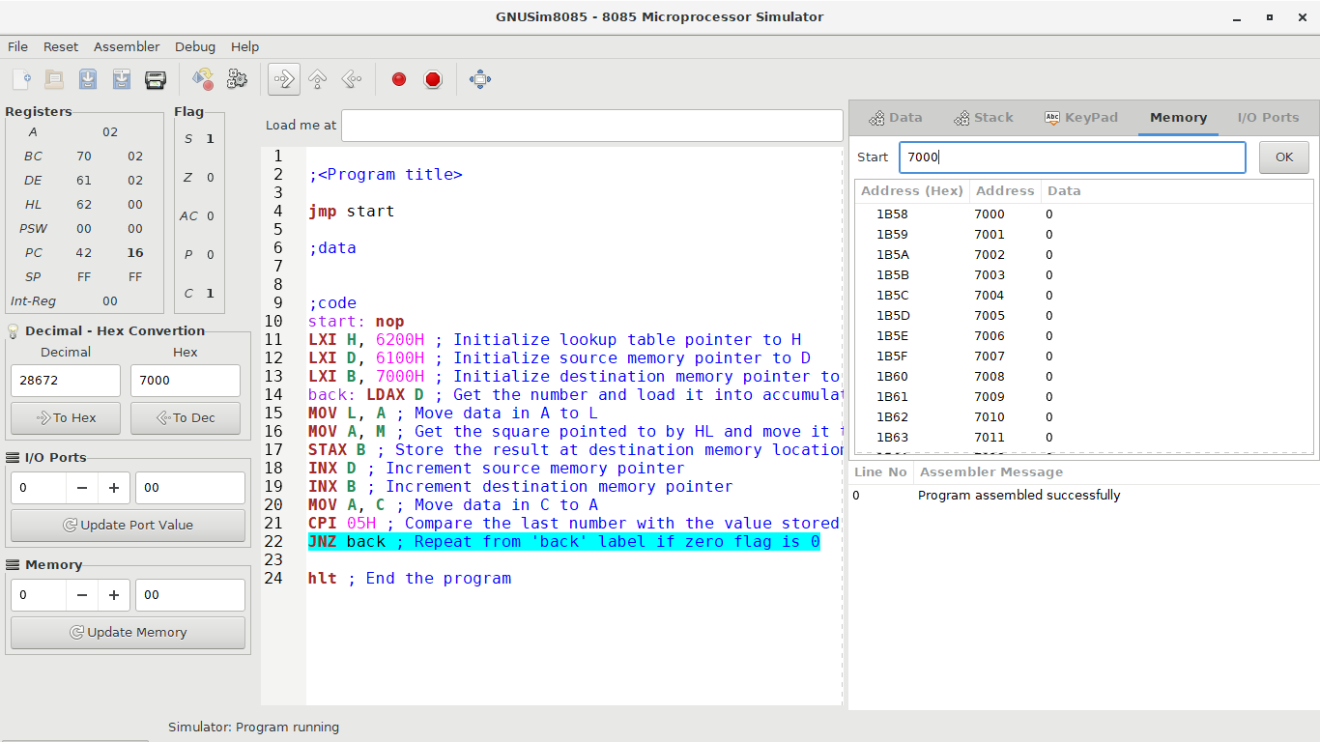

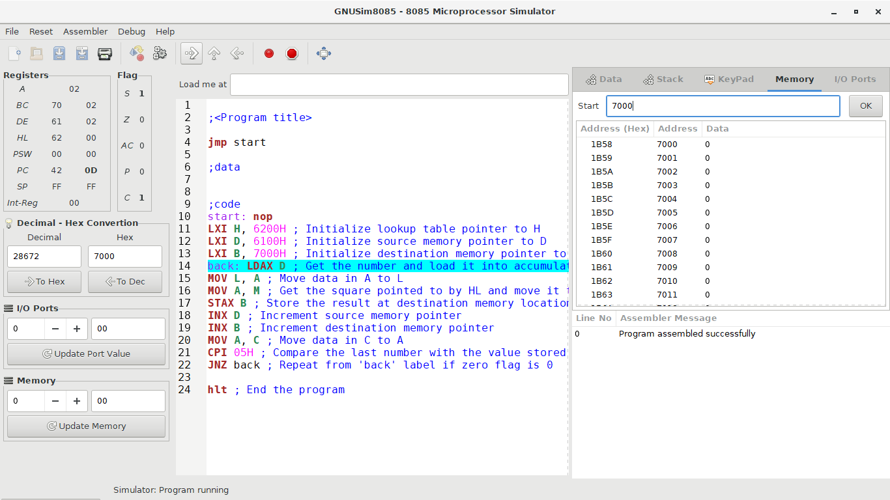

When the accumulator value is 03H:

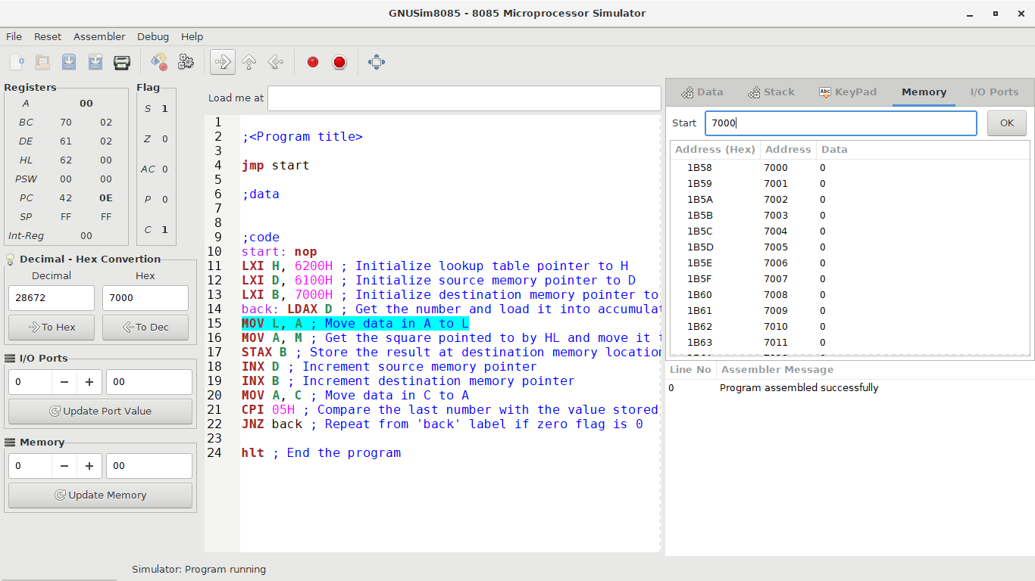

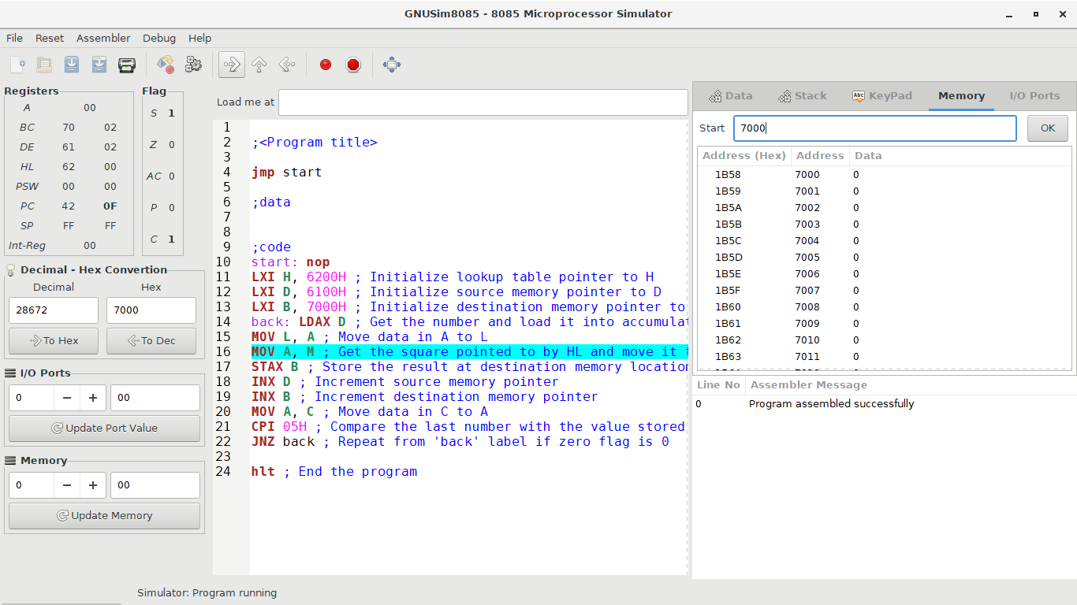

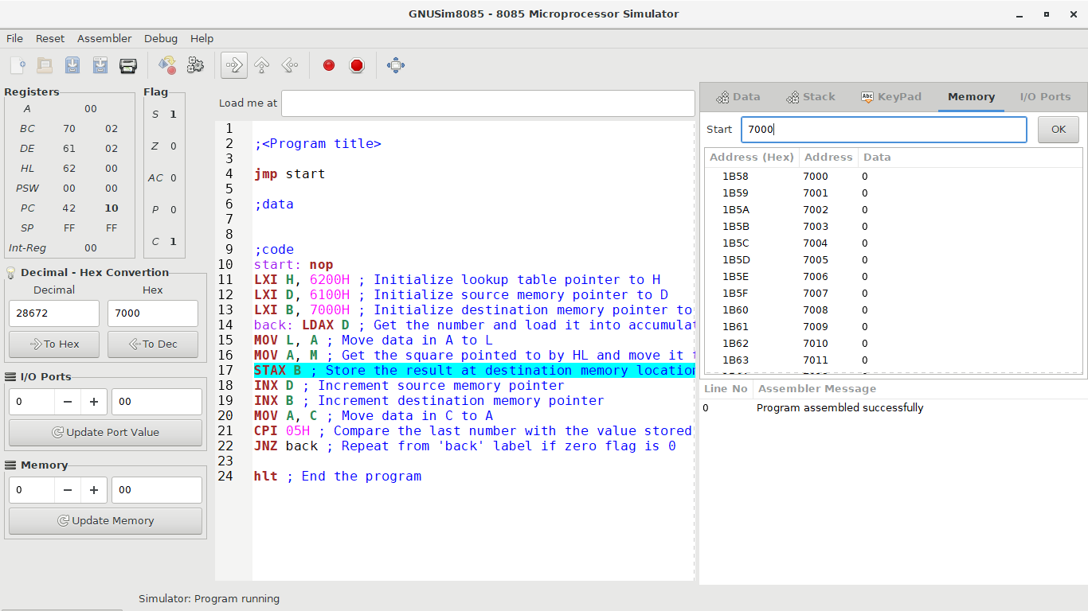

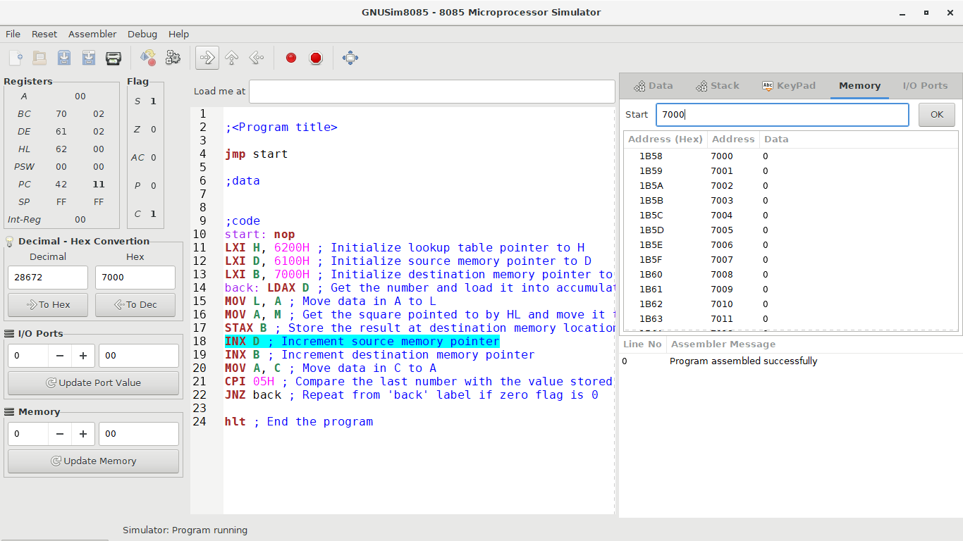

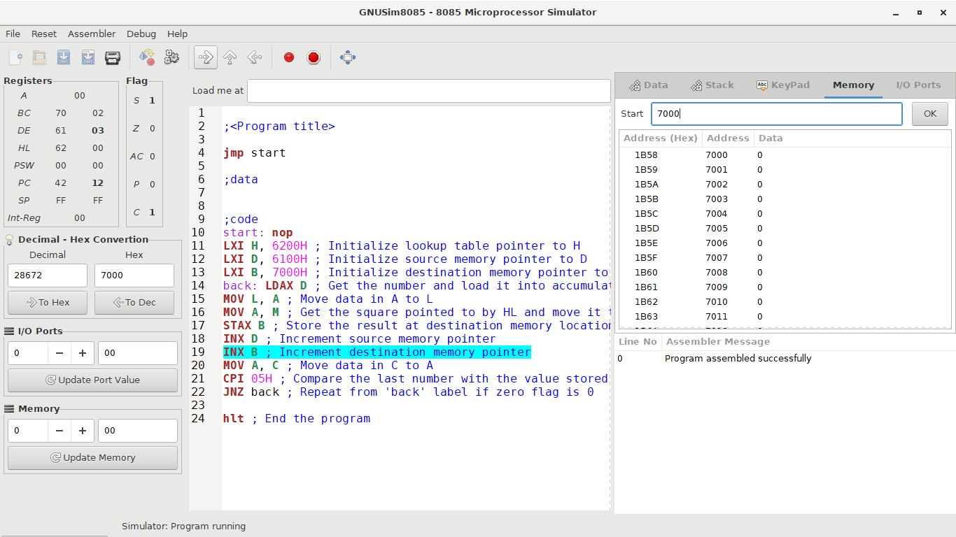

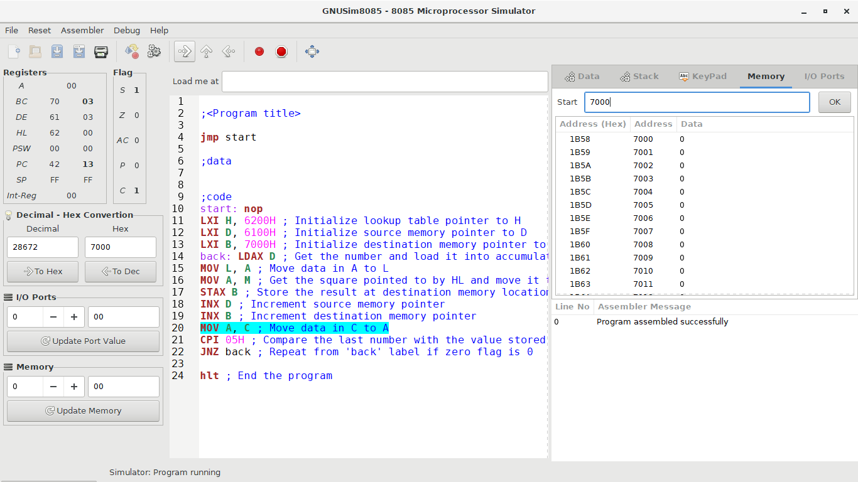

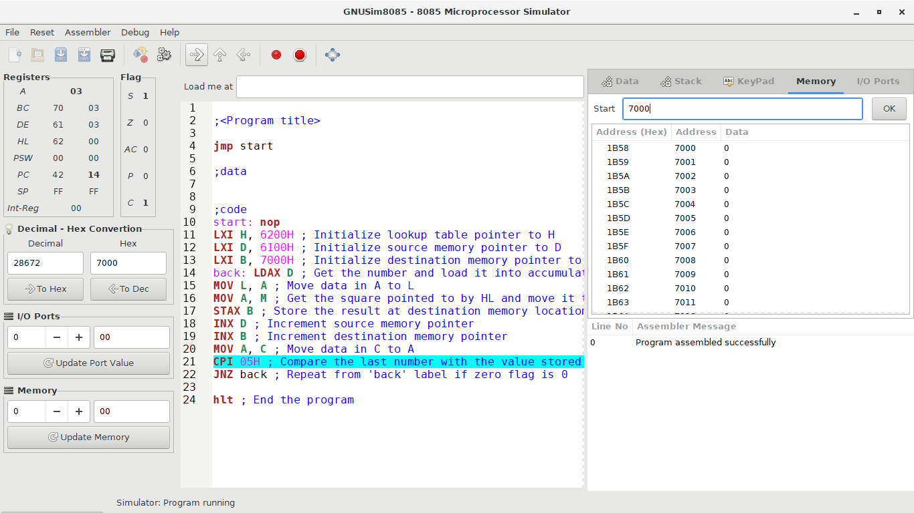

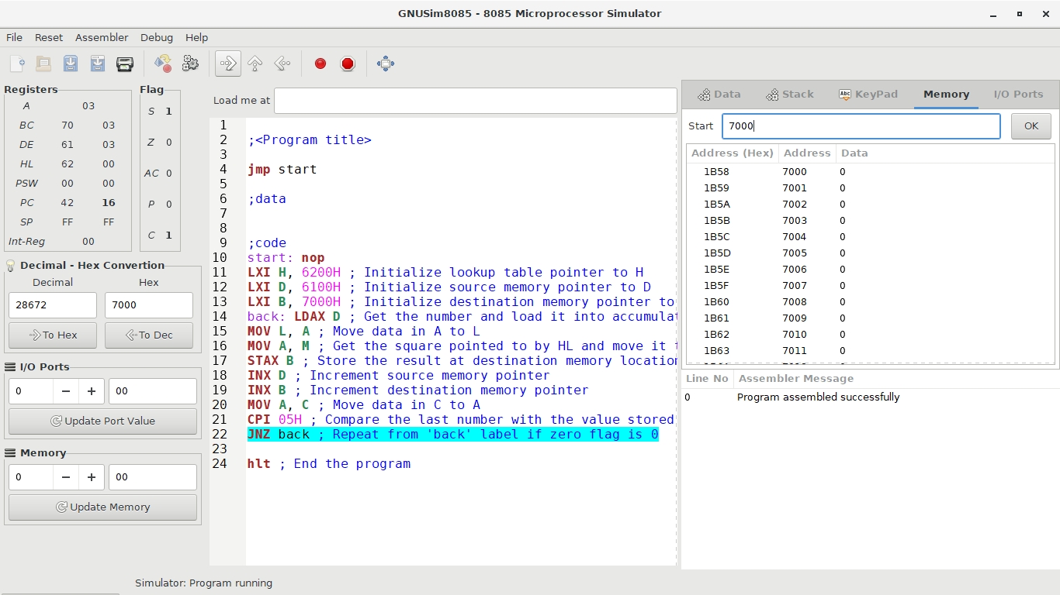

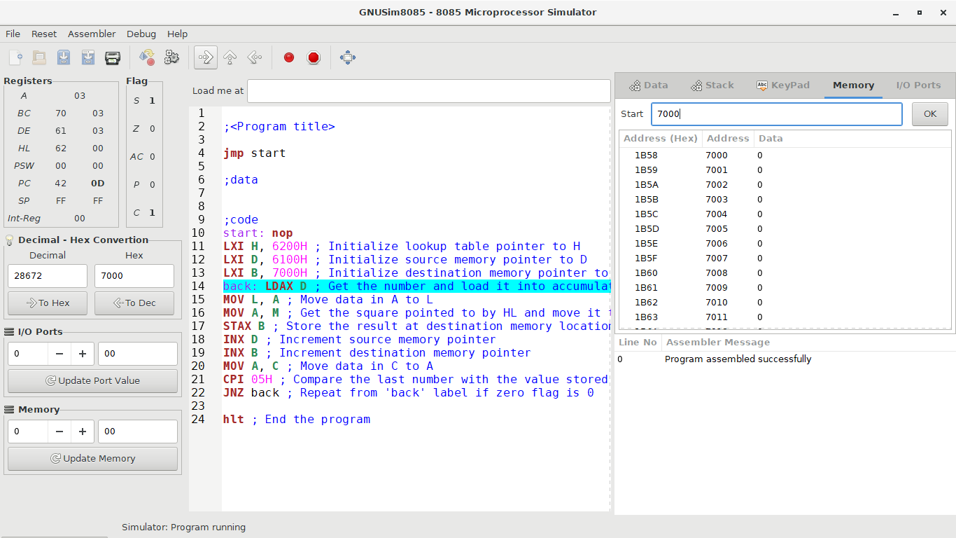

When the accumulator value is 04H:

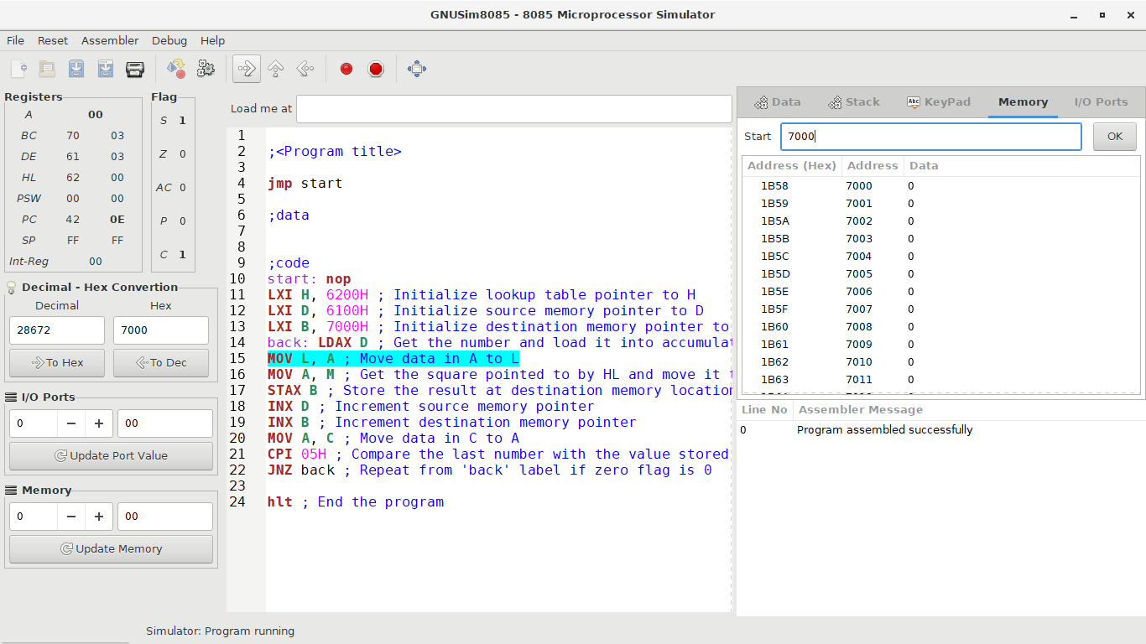

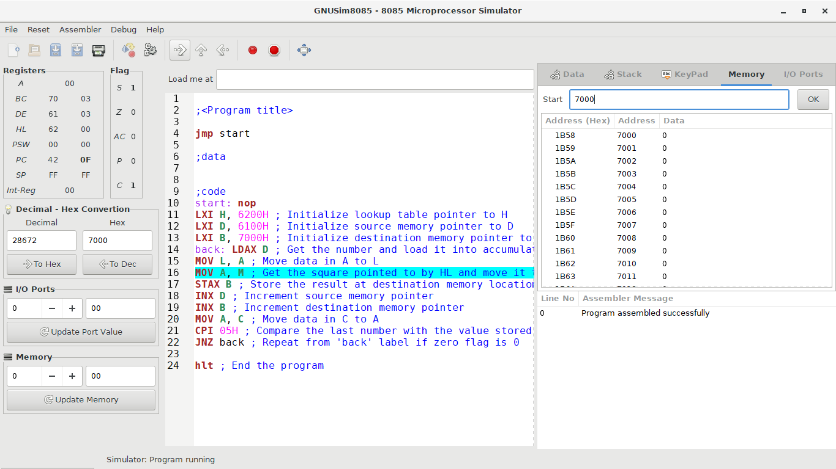

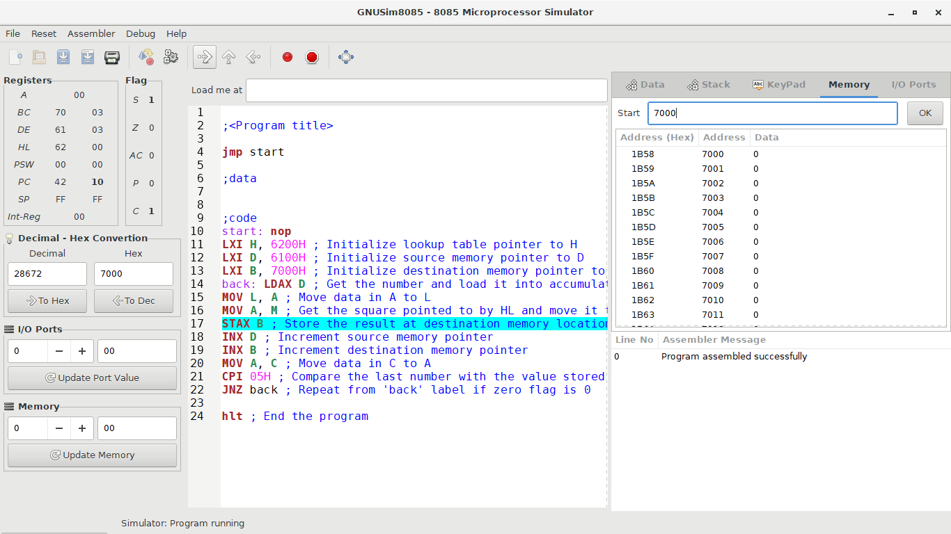

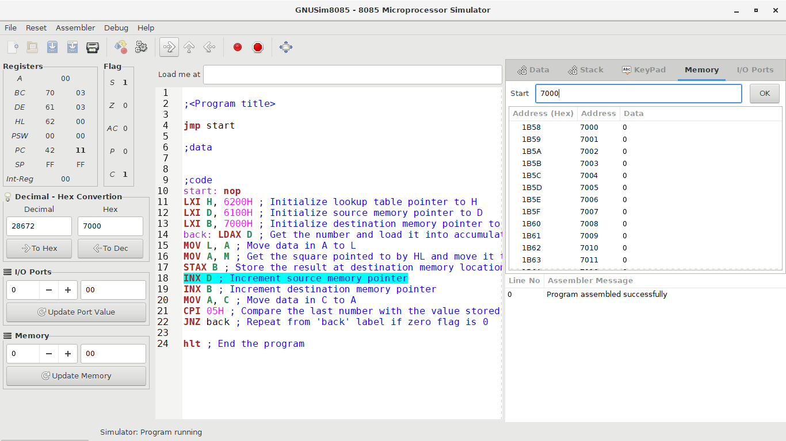

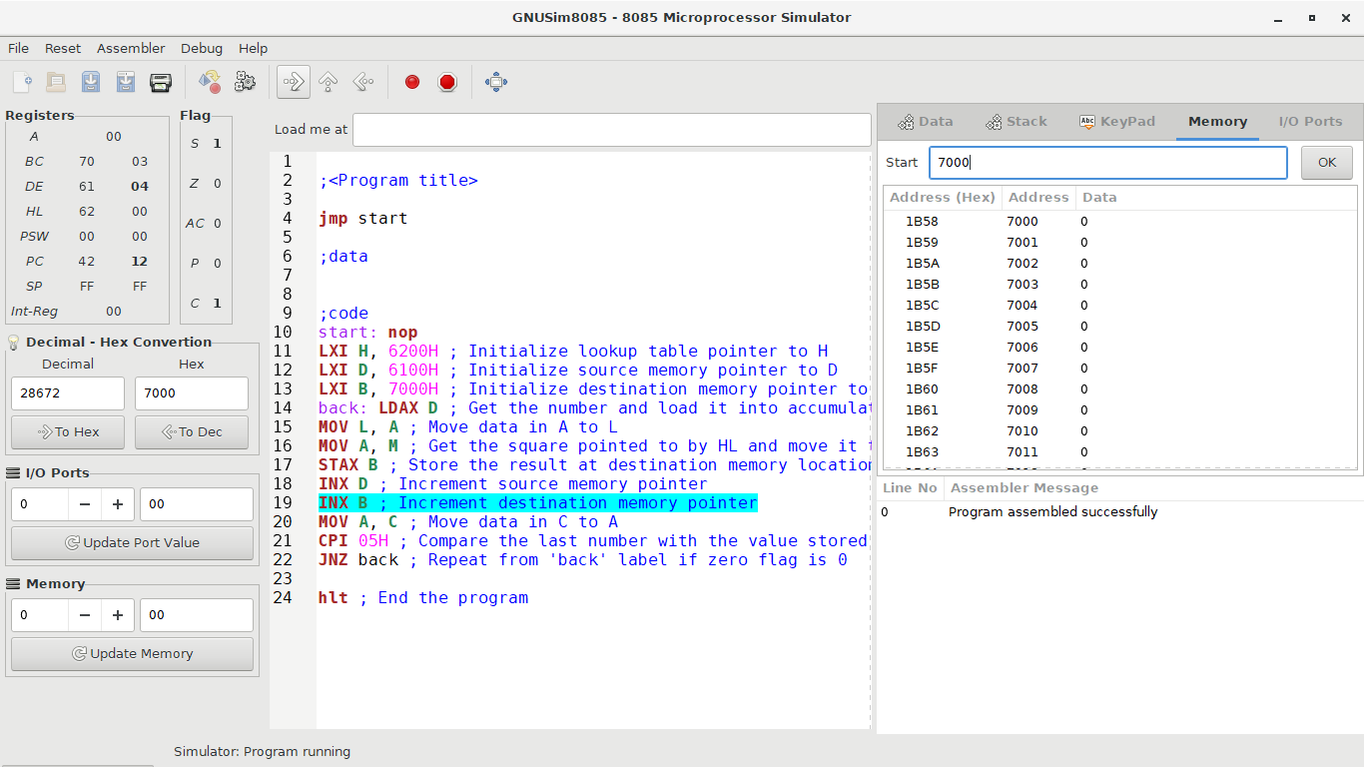

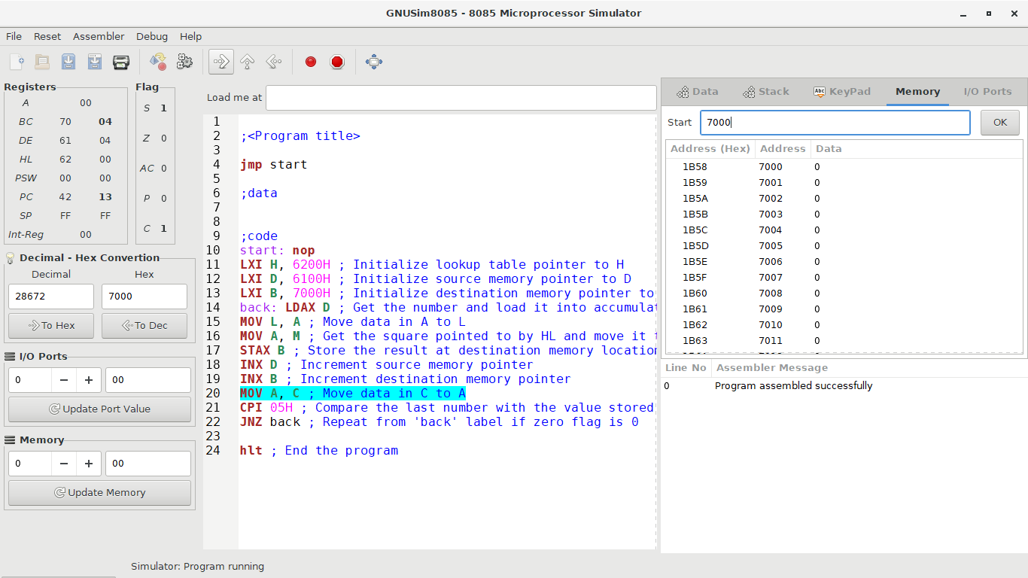

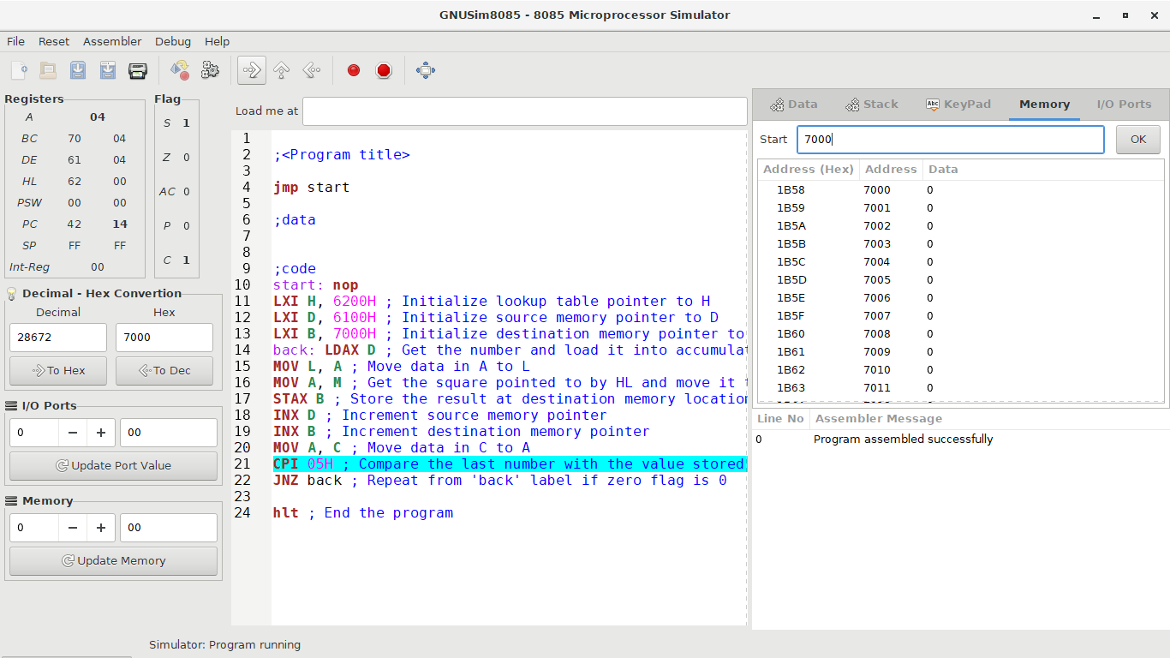

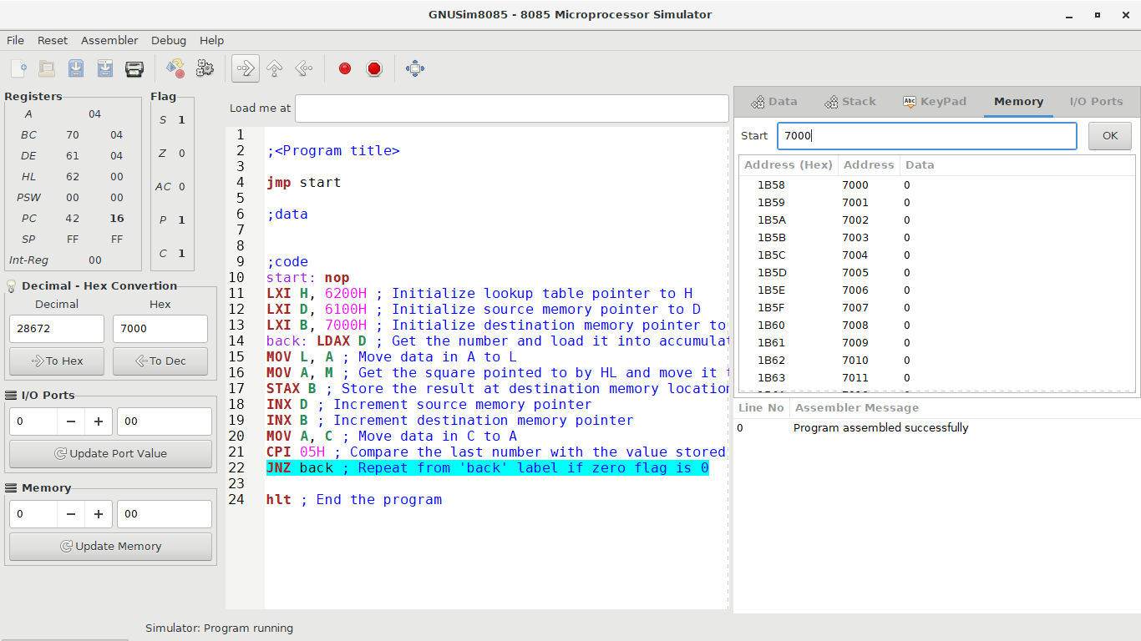

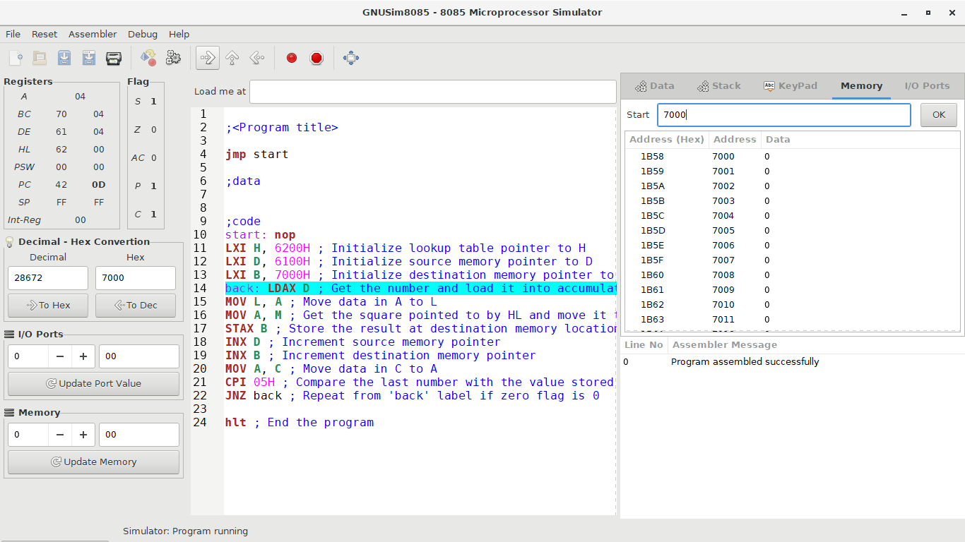

When the accumulator value is 05H:

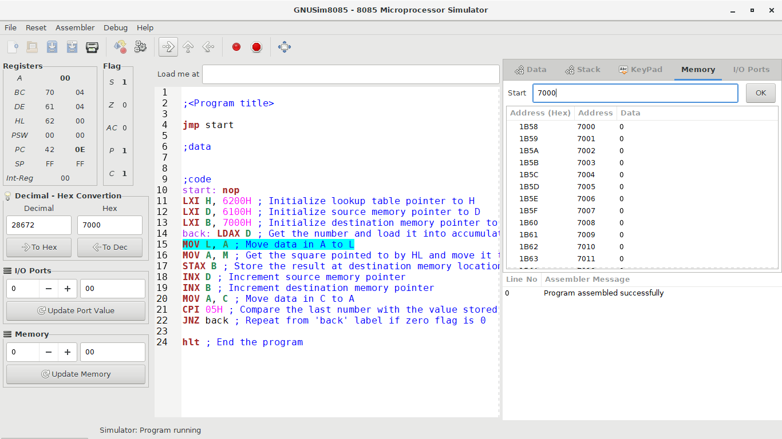

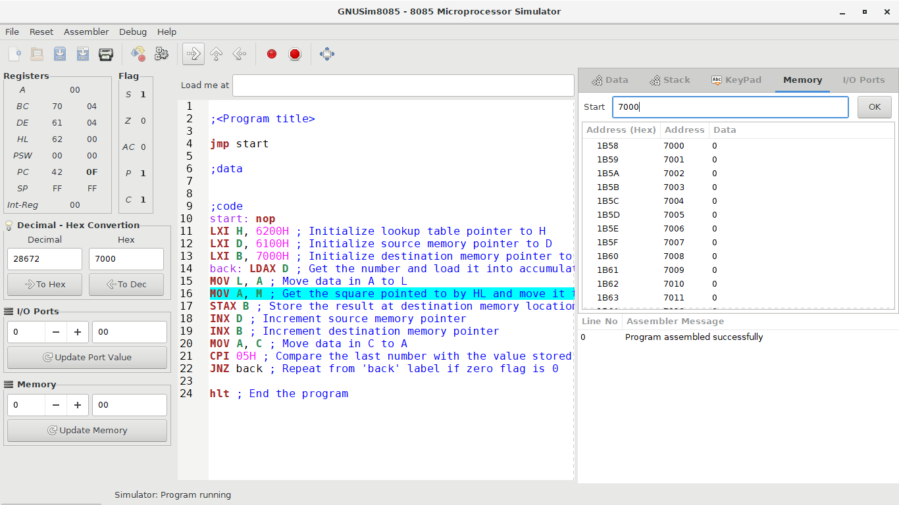

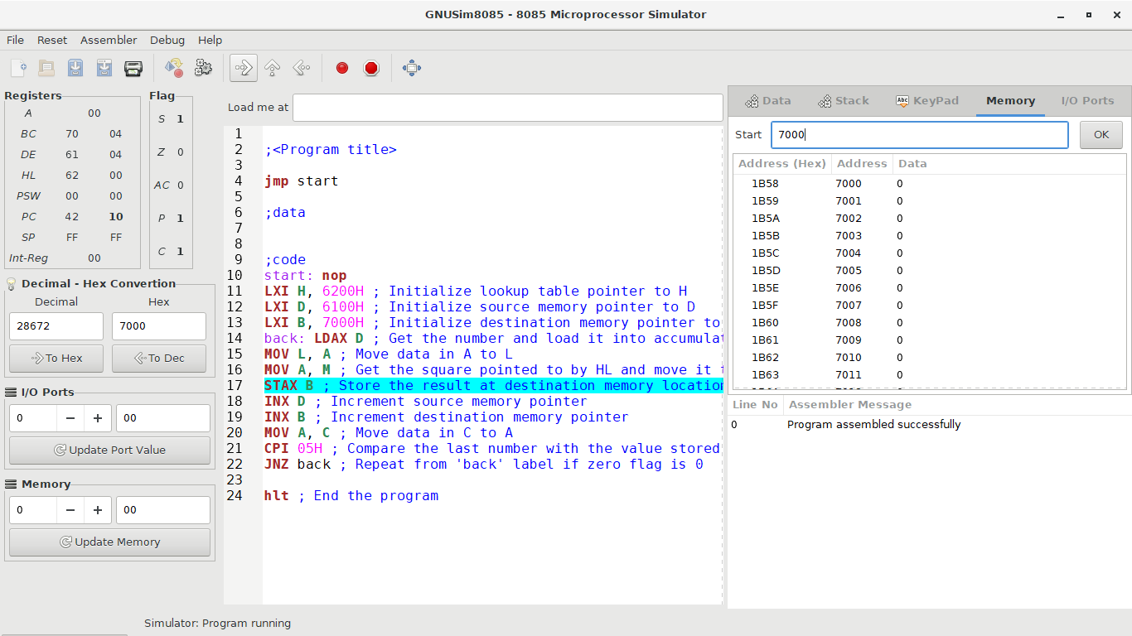

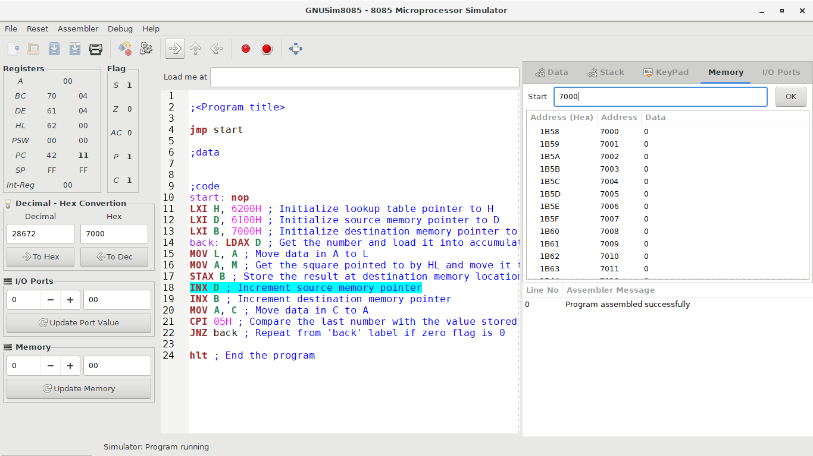

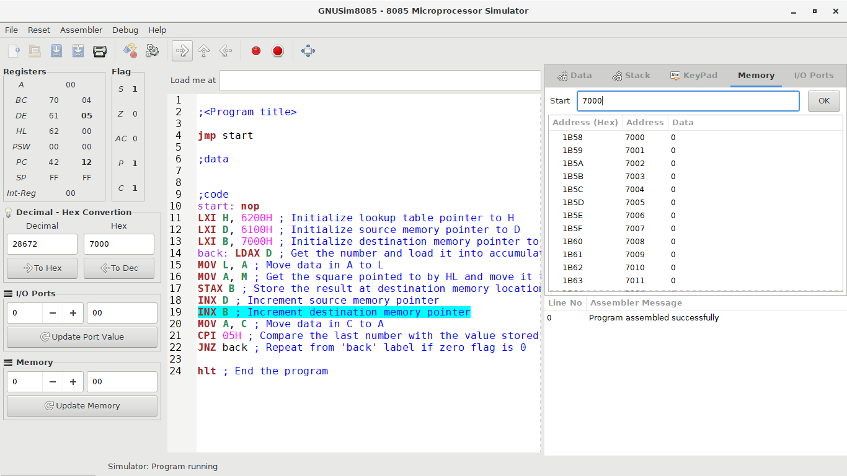

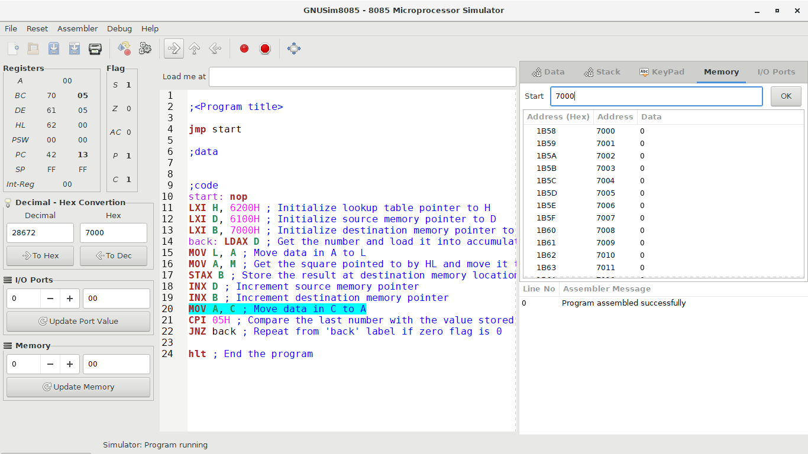

The only change occurs when the contents of the accumulator are 05H as shown below:

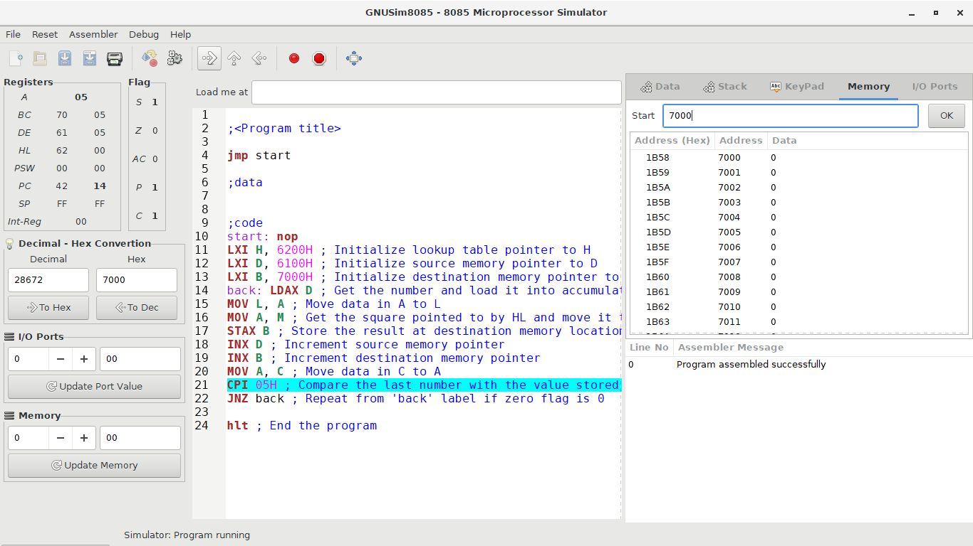

The content of register C will be copied to the accumulator. The program counter is 42 14.

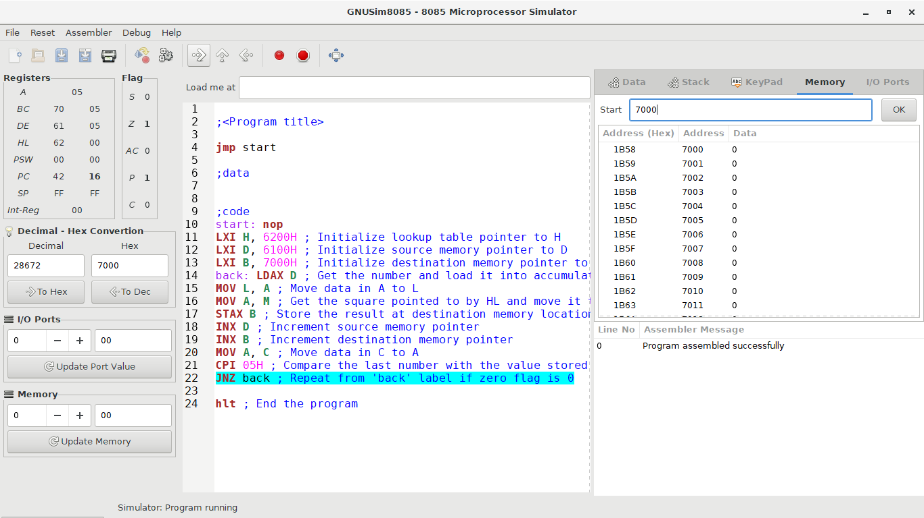

The contents of the accumulator are compared to the value 05H and the result is 05H (Register A) – 05H = -00H. The zero flag is set to 1 and the parity flag is set to 1. The program counter is 42 16.

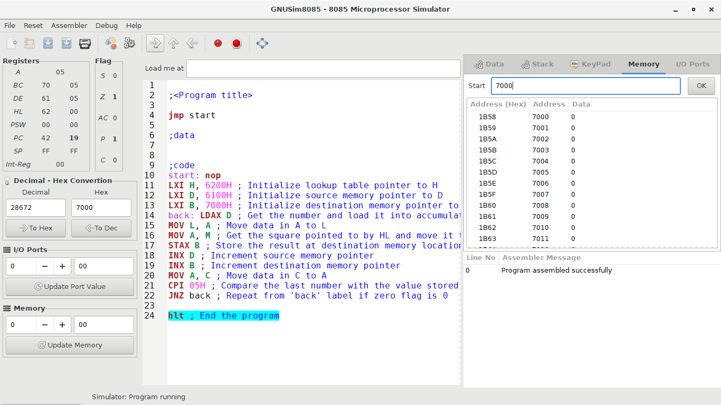

The zero flag is 1 hence, the program proceeds to the next instruction as the conditions for the jump action are not fulfiled.

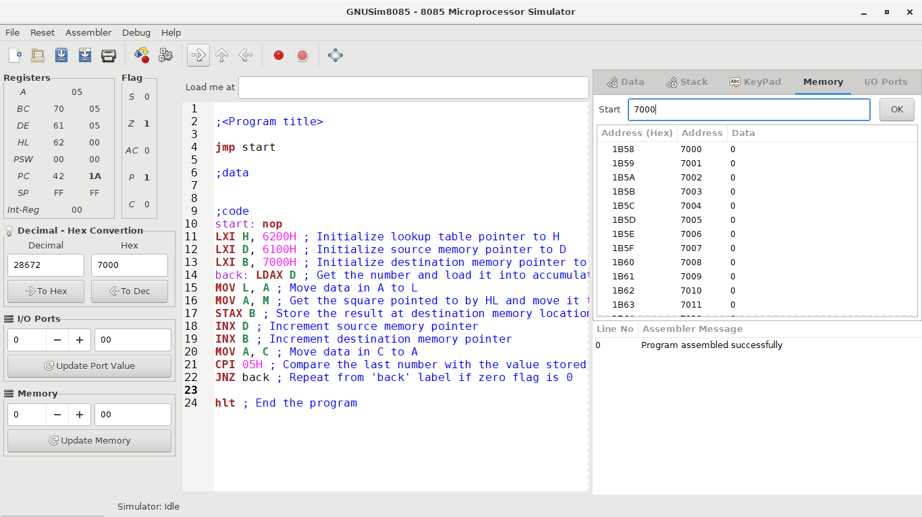

The program terminates from the **hlt** instruction. The program counter is 42 1A.

Thus, the value stored in the lookup table corresponding to the memory location 6205H is the square of 05H. This value is 19H.

**Conclusion**

The GNUSim8085 was used to simulate the process of finding the square of an 8-bit number using a lookup table. The instructions **lxi, ldax, mov, stax, inx, cpi, jnz** and **hlt** were used to achieve this.

**References**

1. Boyini, K. (2018). *Instruction type STAX rp in 8085 Microprocessor*. Tutorialspoint.com. Retrieved 14 January 2021, from https://www.tutorialspoint.com/instruction-type-stax-rp-in-8085-microprocessor#:~:text=In%208085%20Instruction%20set%2C%20STAX,addressing%20for%20specifying%20the%20destination.
2. *Find the square of given number -Free 8085 Microprocessor projects*. 8085projects.info. Retrieved 14 January 2021, from http://www.8085projects.info/Program25.html.
3. John, G. (2018). *Jump if not zero (JNZ) result in 8085 Microprocessor*. Tutorialspoint.com. Retrieved 14 January 2021, from https://www.tutorialspoint.com/jump-if-not-zero-jnz-result-in-8085-microprocessor.
4. Sam, S. (2018). *Instruction type CPI d8 in 8085 Microprocessor*. Tutorialspoint.com. Retrieved 14 January 2021, from https://www.tutorialspoint.com/instruction-type-cpi-d8-in-8085-microprocessor#:~:text=In%208085%20Instruction%20set%2C%20CPI,with%208%2Dbit%20immediate%20data.
5. Sam, S. (2018). *Instruction type INX rp in 8085 Microprocessor*. Tutorialspoint.com. Retrieved 14 January 2021, from https://www.tutorialspoint.com/instruction-type-inx-rp-in-8085-microprocessor#:~:text=In%208085%20Instruction%20set%2C%20INX,of%20the%20following%20register%20pairs.&text=This%20instruction%20will%20be%20used,present%20content%20of%20the%20rp.
6. Sam, S. (2018). *Instruction type LDAX rp in 8085 Microprocessor*. Tutorialspoint.com. Retrieved 14 January 2021, from https://www.tutorialspoint.com/instruction-type-ldax-rp-in-8085-microprocessor#:~:text=In%208085%20Instruction%20set%2C%20LDAX,1%2DByte%20in%20the%20memory.
7. Sam, S. (2018). *Instruction Type LXI rp, d16 in 8085 Microprocessor*. Tutorialspoint.com. Retrieved 14 January 2021, from https://www.tutorialspoint.com/instruction-type-lxi-rp-d16-in-8085-microprocessor.
8. Sam, S. (2018). *Instruction type MOV r, M in 8085 Microprocessor*. Tutorialspoint.com. Retrieved 14 January 2021, from https://www.tutorialspoint.com/instruction-type-mov-r-m-in-8085-microprocessor.
9. Yadav, C. (2019). *8085 program to find square of a 8 bit number*. Tutorialspoint.com. Retrieved 14 January 2021, from https://www.tutorialspoint.com/8085-program-to-find-square-of-a-8-bit-number.

**Question 4: Addition of two 8 bit numbers**

**Aims and Objectives**

* Add two 8-bit numbers from the locations 4150H and 4151H.
* Store the result in location 4152H and 4153H.

**Discussion**

This program intends to add two 8 bit numbers stored in memory. This is done by loading the data from memory into registers and finally storing the result and the state of the carry flag in memory. The following opcodes were used:

* Move Immediate, MVI: loads a specified register with an 8-bit value.
* Load the Accumulator, LDA: loads the accumulator with the contents from a specified memory address.
* Add contents of R to Accumulator, ADD: sums the contents of the specified register and the contents of the accumulator and then stores the result into the accumulator.
* Jump if Not Carry, JNC: jumps to the address provided in the instruction only if the carry flag value is 0.
* Increment, INR: adds 1 with the contents of the specified register and store the result in the register.
* Store in the Accumulator, STA: the contents of the accumulator are copied into the memory location specified by the operand.

For this exercise, the two numbers were 48 stored at 4150H and 23 stored at 4151H. The result was stored at 4152H.

**Results and Analysis**

The complete program is as shown below:

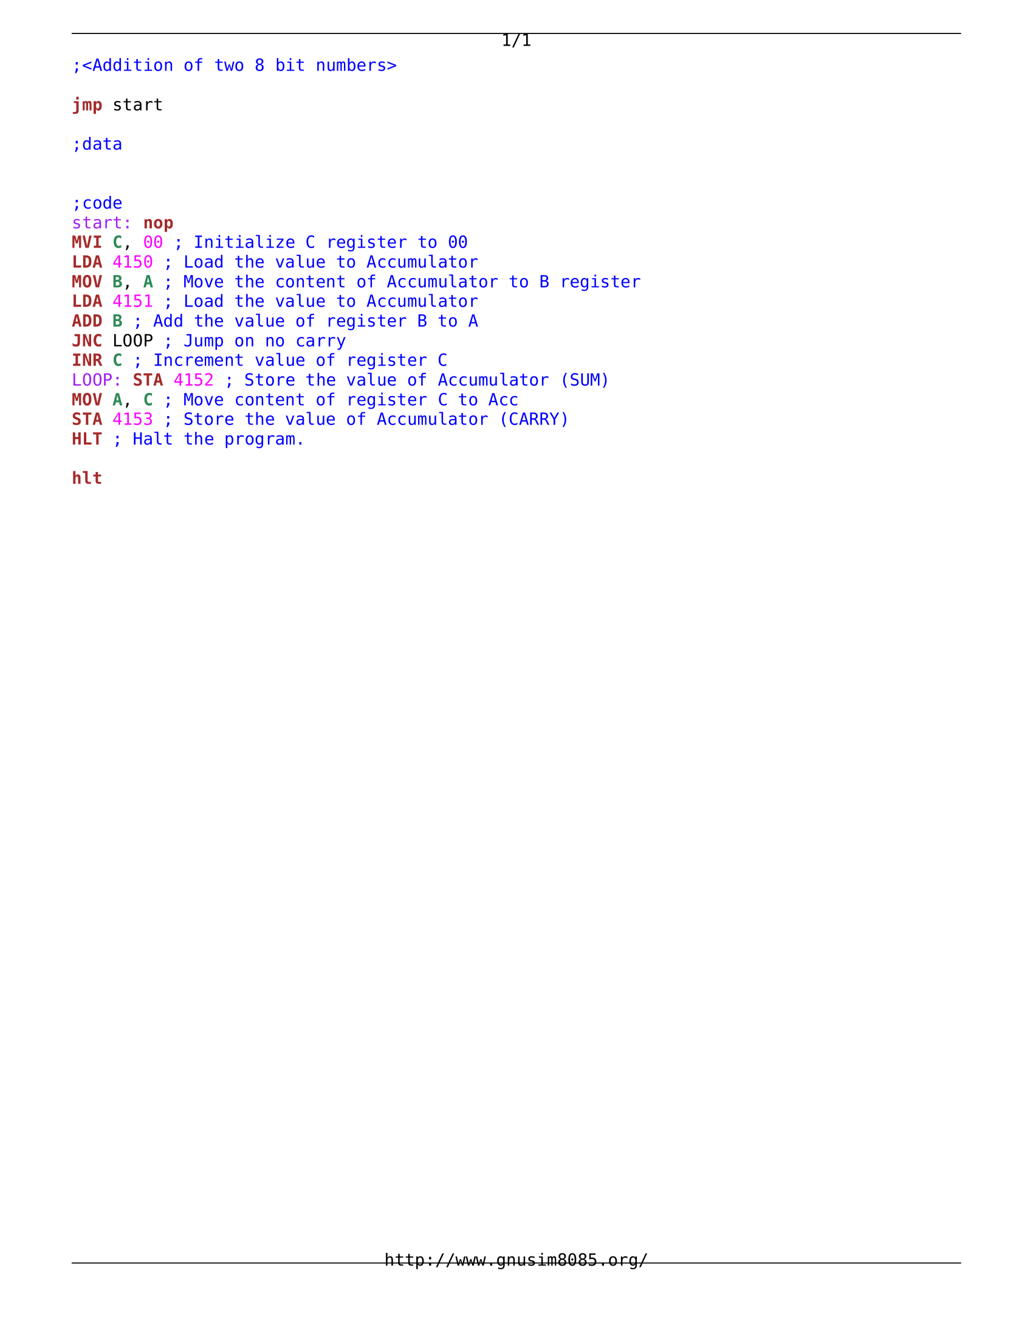

The program sequence is as follows:

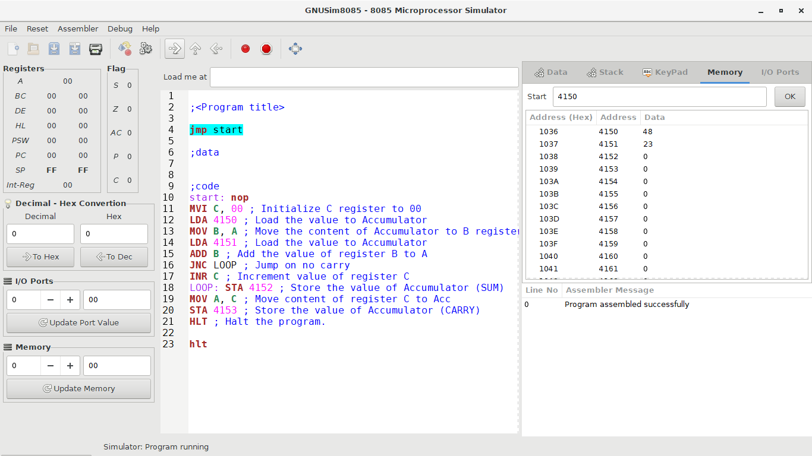

The program starts with the program pointing to the jmp instruction by the program counter set to 00 00.

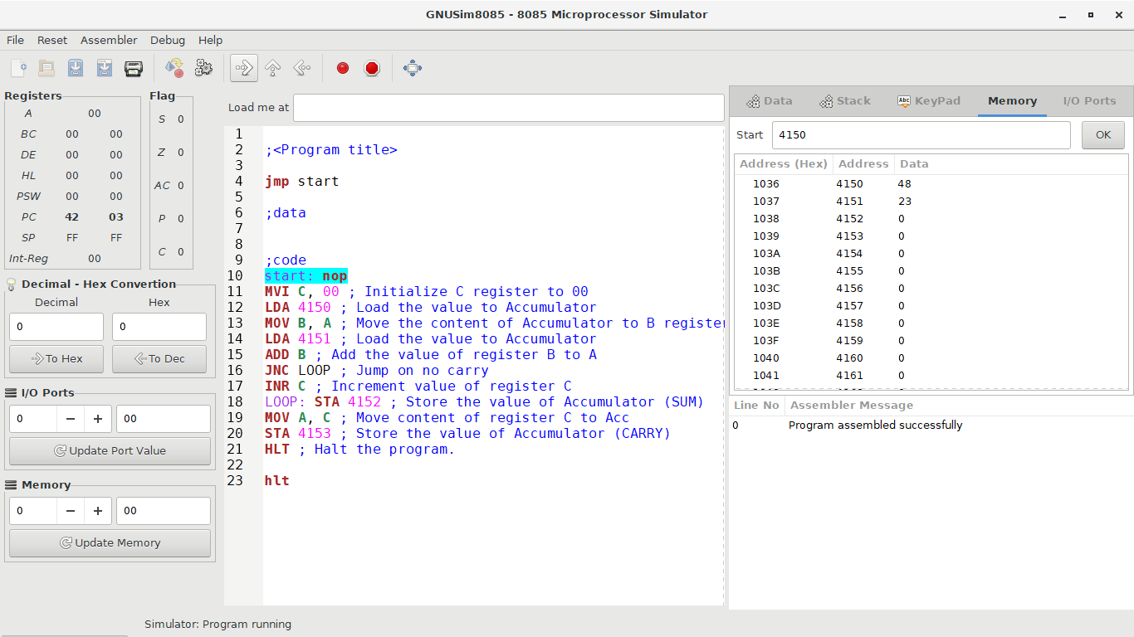

The **jmp** instruction has no conditions and once executed, the program moves to the start label. The program counter is 42 03 as the **jmp** instruction is a 3-bit instruction.

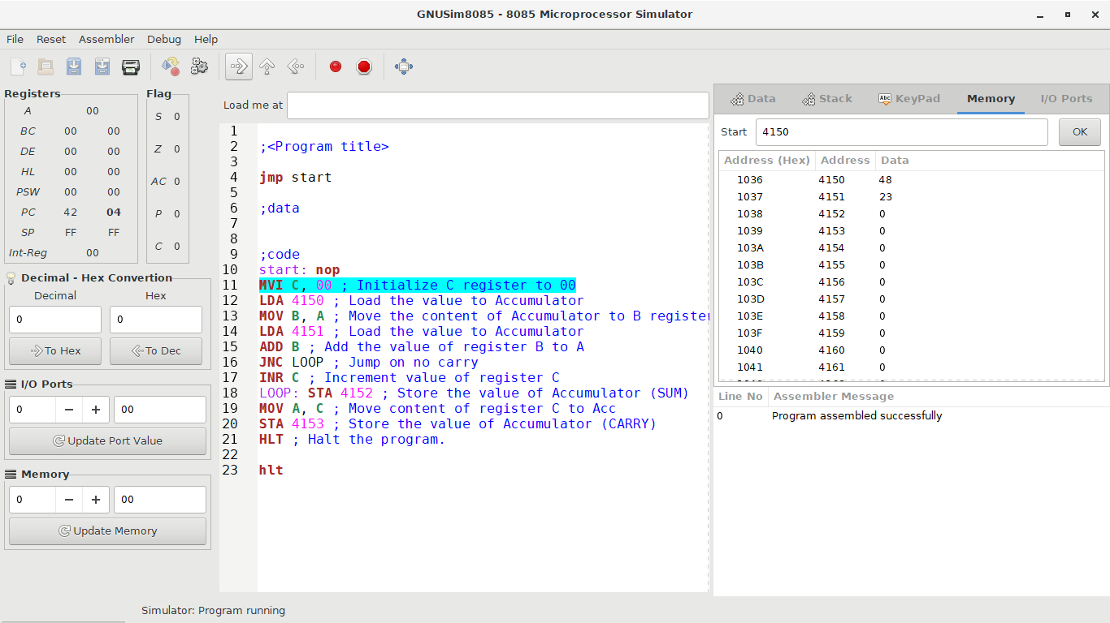

The program jumps to the **start** label. The **nop** instruction does nothing during execution. The program counter is 42 04.

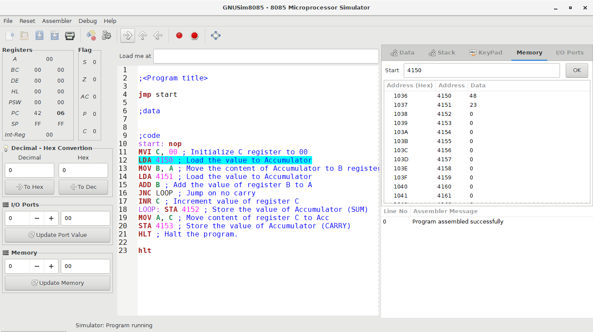

The register C is loaded with the value 00H by the **mvi** instruction to initialise it. The program counter is 42 06.

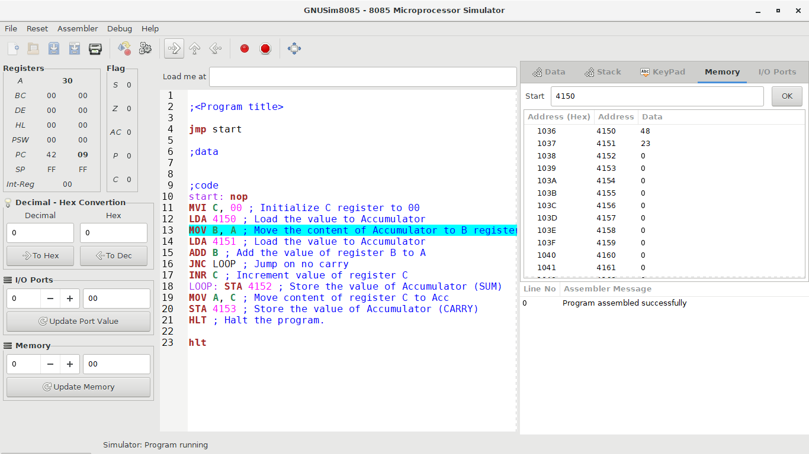

The value, 48, stored at the memory location 4150H is loaded into the accumulator by the **lda** instruction. Thus, the accumulator now holds the value 30H. The program counter is 42 09.

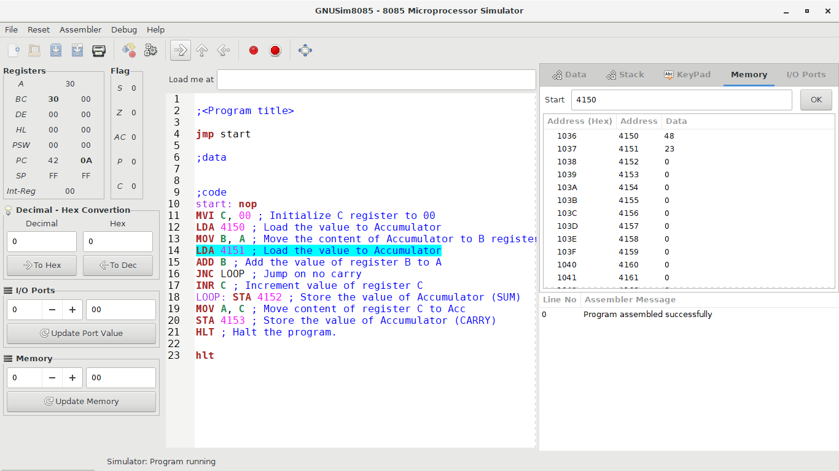

The contents of the accumulator are copied to register B by the instruction **mov**. The program counter is 42 0A.

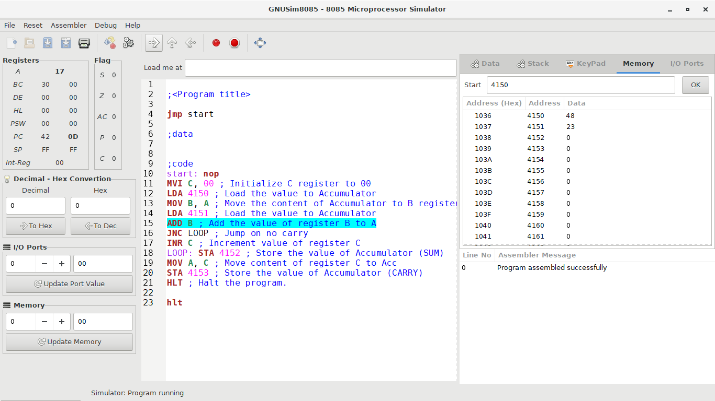

The value, 23, stored at the memory location 4151H is loaded into the accumulator by the **lda** instruction. Thus, the accumulator now holds the value 17H. The program counter is 42 0D.

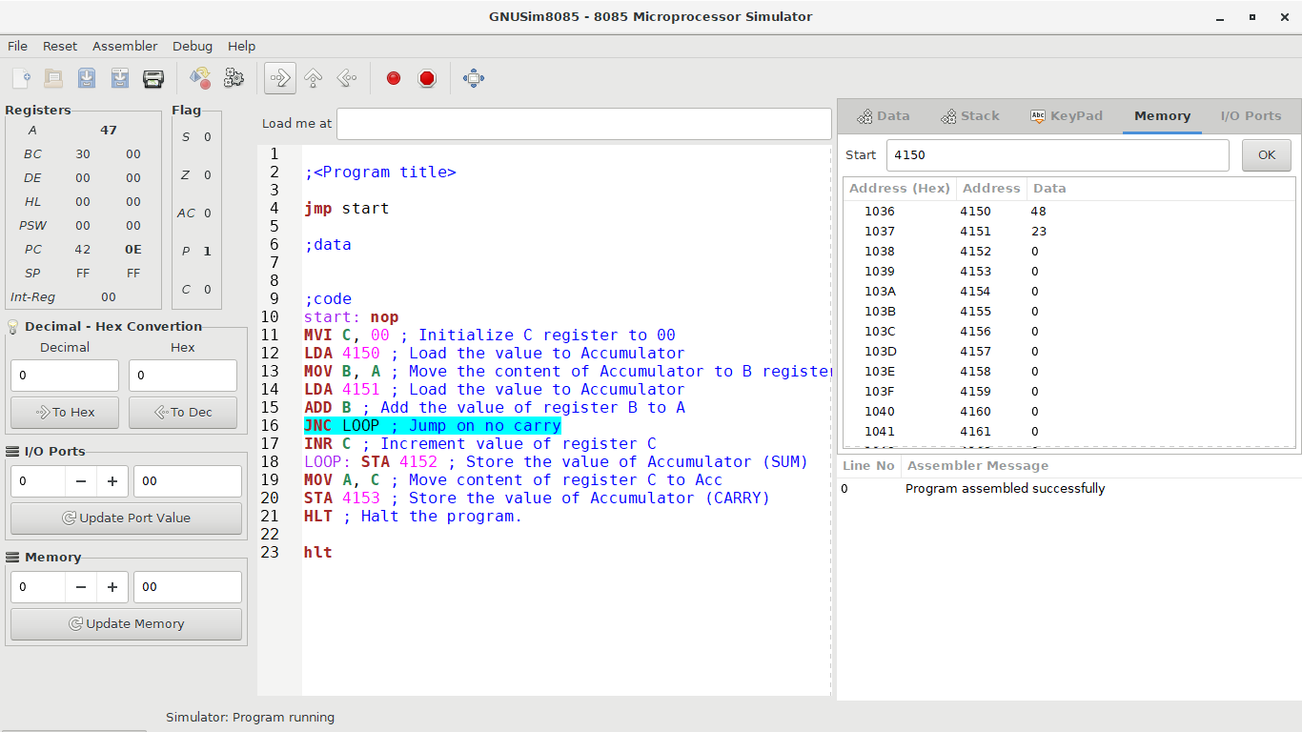

The contents of register B are added the contents of the accumulator by the **add** instruction. The program counter is 42 0E.

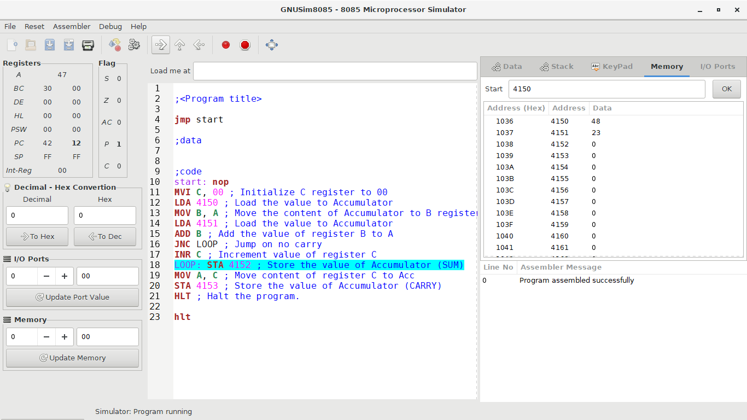

As there is no carry from the result of the **add** operation, the condition for the **jnc** instructions are met. That is, the carry flag is 0. Thus, the program jumps the **inr** instruction and moves on to the **loop** label. The program counter is 42 12.

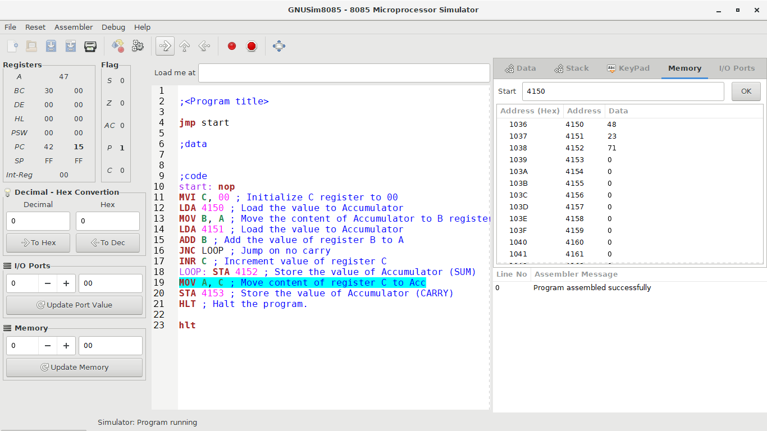

The contents of the accumulator are stored in the memory location 4152H by the **sta** instruction. The program counter is 42 15.

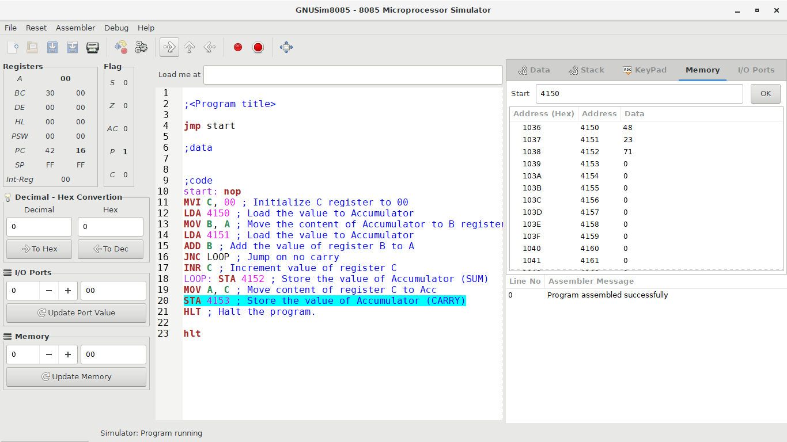

The contents of register C are copied to the accumulator by the **mov** instruction. The program counter is 42 16.

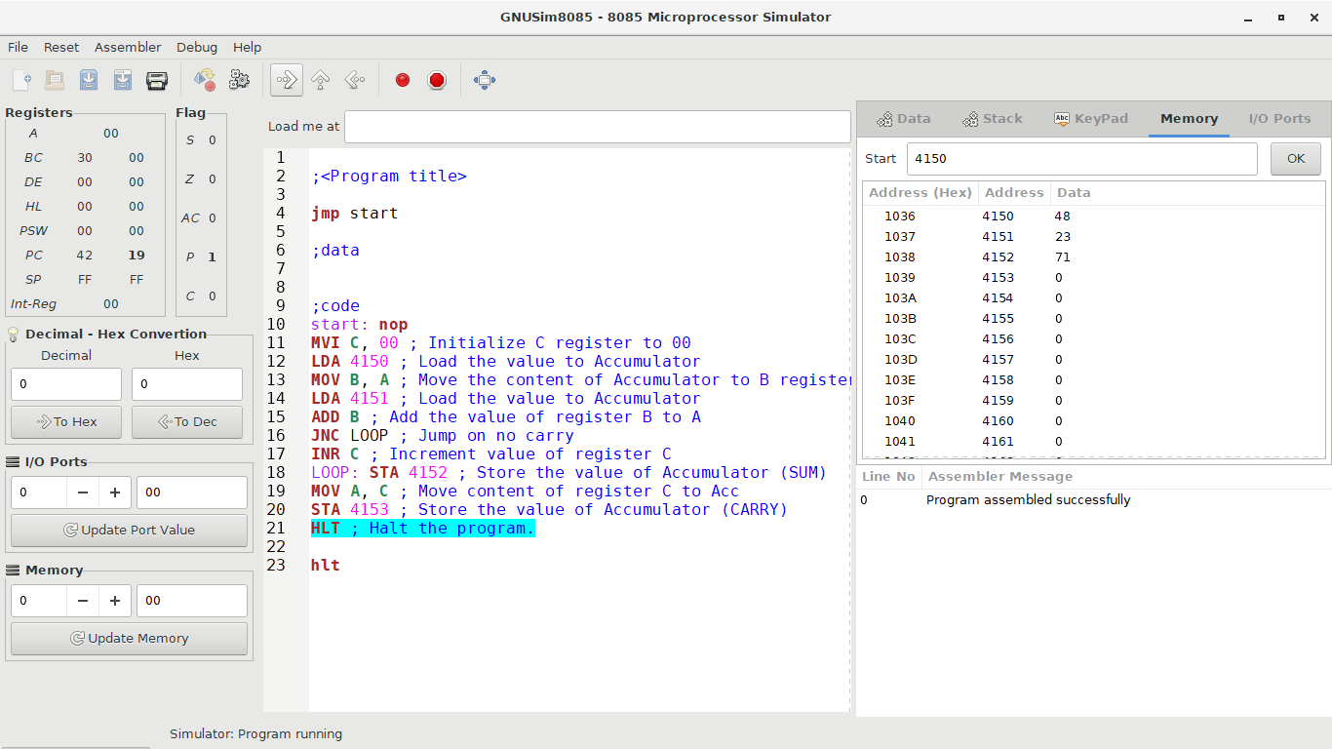

The value of the carry flag is stored in the memory location 4153H. As it is 0, there is no visible change. The program counter is 42 19.

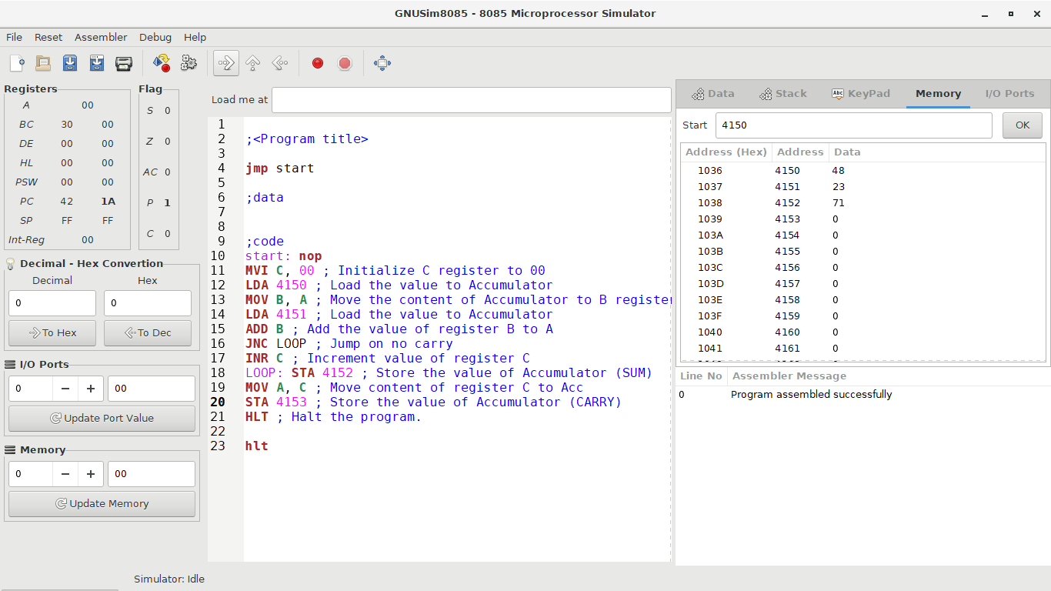

After execution of the **hlt** instruction, the program is terminated. The program counter is 42 1A.

Thus, the addition of the two numbers is carried out and the result stored in the memory locations 4152H and 4153H.

**Conclusion**

The GNUSim8085 was used to simulate the process of adding two 8-bit numbers from memory and storing the result in the memory of the 8085 microprocessor. The instructions **mvi, lda, add, jnc, inr, sta** and **hlt** were used to achieve this. The two numbers used were 48 and 23 and the result of the program was 71 as the sum and 0 as the carry.

**References**

1. Boyini, K. (2018). *Instruction type LDA a16 in 8085 Microprocessor*. Tutorialspoint.com. Retrieved 14 January 2021, from https://www.tutorialspoint.com/instruction-type-lda-a16-in-8085-microprocessor#:~:text=In%208085%20Instruction%20set%2C%20LDA,addressing%20for%20specifying%20the%20data.
2. Boyini, K. (2018). *Instruction type NOP in 8085 Microprocessor*. Tutorialspoint.com. Retrieved 14 January 2021, from https://www.tutorialspoint.com/instruction-type-nop-in-8085-microprocessor.
3. John, G. (2018). *Jump if not Carry (JNC) in 8085 Microprocessor*. Tutorialspoint.com. Retrieved 14 January 2021, from https://www.tutorialspoint.com/jump-if-not-carry-jnc-in-8085-microprocessor.
4. Sam, S. (2018). *Instruction type ADD R in 8085 Microprocessor*. Tutorialspoint.com. Retrieved 14 January 2021, from https://www.tutorialspoint.com/instruction-type-add-r-in-8085-microprocessor.
5. Sam, S. (2018). *Instruction type INR R in 8085 Microprocessor*. Tutorialspoint.com. Retrieved 14 January 2021, from https://www.tutorialspoint.com/instruction-type-inr-r-in-8085-microprocessor#:~:text=In%208085%20Instruction%20set%2C%20INR,M%20pointed%20by%20HL%20pair.&text=This%20instruction%20is%20used%20to,increased%20by%20amount%201%20only.
6. Sam, S. (2018). *Instruction type MVI r, d8 in 8085 Microprocessor*. Tutorialspoint.com. Retrieved 14 January 2021, from https://www.tutorialspoint.com/instruction-type-mvi-r-d8-in-8085-microprocessor.
7. Sam, S. (2018). *Instruction type STA a16 in 8085 Microprocessor*. Tutorialspoint.com. Retrieved 14 January 2021, from https://www.tutorialspoint.com/instruction-type-sta-a16-in-8085-microprocessor#:~:text=In%208085%20Instruction%20set%2C%20STA,addressing%20for%20specifying%20the%20destination.
8. Thakur, A. (2019). *8085 Program to Add two 8 Bit numbers*. Tutorialspoint.com. Retrieved 14 January 2021, from https://www.tutorialspoint.com/8085-program-to-add-two-8-bit-numbers.